Industrial Training-Project Report

(MCA-C651)
On
Student Result Management System

Submitted in partial fulfillment of the requirements
for the award of the degree of

Master of Computer Applications (MCA)

Uttaranchal School of Computing Sciences



BATCH 2024-2026

Submitted by:
Submitted to:

Gautam Kumar Gupta
UU2420000036
MCA -IV (B)
Uttaranchal School of Computing Sciences
Mr.Praveen Shah

Assistance Professor

ACKNOWLEDGEMENT

The most awaited moment of any endeavor is its successful completion, but nothing can be done successfully if done alone. “Success is the outcome of continuou’s technical mentoring, guidance, and support from various individual’s, and I express my sincere gratitude to all those who contributed to the successful completion of this project.
First and foremost, “I would like to thank Prof. (Dr.) Sonal Sharma, Director, USCS, for providing a healthy and encouraging environment for study”.
I am extremely thankful to “Prof.(Dr.) Sameer Dev Sharma”, Head of Department, USCS, and my project mentor “Mr.Praveen Shah”, for providing me with this opportunity and for their valuable technical mentorship, continuous guidance, and expert insights throughout the project development process. “Their support at every stage significantly enhanced my understanding and helped me successfully complete this work”.
I also express my sincere gratitude to my colleague’s for their valuable discussion’s and support, which helped me in giving a final shape to this project.

Date: Gautam Kumar Gupta
UU2420000036
MCA -IV“B”

STUDENT DECLARATION

I hereby declare that the project titled “Student Result Management System” is an original work carried out by me under the guidance of “Mr.Praveen Shah” in partial fulfillment of the requirement’s for the award of the degree of “Master Of Computer Application’s (MCA)” from “Uttaranchal University”.
“I further declare that this project has not been submitted, either in part or in full, to any other institution or university for the award of any degree or diploma”.
All source’s of information and reference’s used in this project have been duly acknowledged.

Date: Gautam Kumar Gupta
UU2420000036
MCA-IV “B”

Uttaranchal School of Computing Sciences

CERTIFICATE

“This is to certify that the project work entitled “Student Result Management System” is a bonafide work carried out by “Gautam Kumar Gupta” (UU2420000036) submitted in partial fulfilment for the award of the degree in “MASTER OF COMPUTER APPLICATIONS” of “Uttaranchal University”, ‘Dehradun’ during the academic year 2025-26”.
It is verified that the project file’s and project report (PDF) are uploaded on GitHub [https://github.com/Gautamkr18/SRMS]

Mr.Praveen Shah Assistant Professor
USCS

Industry Training Certificate

PREFACE

“This project report titled “Student Result Management System” has been prepared as a partial fulfilment for the award of the degree of “Master of Computer Applications”. The objective of this project is to apply theoretical concepts to real-world problem’s and to gain practical exposure in design, development, and implementation.
[“SRMS automate’s student result management, replacing error-prone manual processe’s with a secure web platform. Built with PHP, MySQL, and Bootstrap, it enables admins to manage classe’s, subject’s, student’s, and result’s while allowing student’s to instantly view their marks online. Key outcome’s include reduced publication delay’s, centralized data, and role-based access”.]
The project files are uploaded on GitHub [https://github.com/Gautamkr18/SRMS]

Mr. Praveen Shah Gautam Kumar Gupta
Assistant Professor UU2420000036

TABLE OF CONTENTS
S.No. | Contents | Page.No
I | Acknowledgement | 1
II | Declaration | 2
III | Certificate | 3
1. | Introduction | 4
2. | Objective | 5
3. | Feasibility Study  3.1 Technical Feasibility  3.2 Economic Feasibility  3.3 Operational Feasibility | 6  7  8  9
4. | System Analysis  4.1 Challenges in Existing Systems  4.2 Proposed Solutions  4.3 Functional Overview | 10  10  10  11
5. | Requirement Analysis  5.1 Functional Requirements  5.2 Non-Functional Requirements  5.3 Software Requirements  5.4 Hardware Requirements | 12  12  13  13  14
6. | System Design  6.1 Use Case Diagram  6.2 ER Diagram  6.3 Data Flow Diagram | 15  16  17  18
7. | Project Planning  7.1 Gantt Chart  7.2 PERT Chart  7.3 SDLC Phases | 19  20  21  22
8. | Technical Details  8.1 Frontend Technologies  8.2 Backend Technologies  8.3 Database | 23  23  24  24
9. | Testing and Implementation  9.1 Test Plan  9.2 Results and Analysis | 25  26  27

10. | Limitations and Future Scope  10.1 Current Limitations  10.2 Potential Enhancements | 28
11. | Conclusion | 29
12. | Coding  12.1 Input  12.2 Output | 30-73
13. | Bibliography & Reference | 74

- INTRODUCTION

“One of the biggest pain-point’s that educational institutions run into is to manage, process and distribute student academic result’s”. Conventional processe’s, like using physical result sheets, printed mark sheets and files on standalone spreadsheet are error-prone, do not provide real-time access to information or analytics and often take weeks to publish results. “Result’s are often delayed for a long time, and students/parents have to visit administrative offices in seeking the results. Additionally, coordination of result data become’s more tedious and cumbersome when dealing with multiple classes/subjects & academic year’s”.
So, to tackle the above issues “we have developed a web-based application called Student Result Management System (SRMS)”. It offers a centralised automated interface for administrators to manage student data, information on classe’s and subjects along with master-data of the subject combinations available and students results. “HTML CSS (Bootstrap), JavaScript, server-side logic in ‘PHP’ and ‘MySQL’ for database storage. This tech stack helps you to make the application stable, secure and device-agnostic”.
The ‘SRMS’ has two main interface’s: “A search page for student results that is open to the public and a full admin panel. Student’s can see their results by entering their roll number and choosing their class”. The admin panel lets people with the right permissions do everything they need to do, like adding students, making classes, defining subject’s, setting subject combinations for each class, posting notices, declaring result’s, and managing user account’s. “This system makes the whole process of managing results easier, cut’s down on mistake’s made by hand, and gives students quick, safe access to their academic result’s”.

OBJECTIVE

The main goal of the “Student Result Management System” is to give student’s an easy-to-use, accurate, and efficient digital platform for keeping track of their academic data and result’s. “Data redundancy, delayed result publication, lack of centralisation, and difficulty in result retrieval are common problems with existing manual or semi-digital system’s”.
The ‘PHP’ and ‘MySQL’-based system solve’s these problem’s by combining secure data management, instant result publication, and easy access[1].
Key Objectives:
- Centralized Data Management: “To keep all of the students' information, class schedules, subject list’s, and test scores in one safe database, getting rid of data silos and duplication”.
- Automated Result Processing: “To let administrators declare results by subject combination and automatically store marks and figure out totals and percentages (done at display time)”.
- Instant Result Publication: “This lets students see their results online right away by entering their roll number and choosing their class, without any help from staff”.
- Efficient Administrative Workflow: “To make it easy to manage classes, subject’s, subject combination’s, student registrations, notices, and user profiles with an easy-to-use admin panel”.
- Secure Access Control: “To set up role-based access so that only verified administrators can change sensitive information and students can only read their own result’s.
- Transparent Communication: “To post important information on the public-facing homepage so that student’s and parents can stay up to date on exam schedules, result announcement’s, and other news[4]”.
- Reduce Manual Effort: “To lessen the administrative load of printing, distributing, and keeping track of physical mark sheet’s, which will save time and money”.
“In general, the SRMS's goal is to update the process for managing academic result’s so that it is faster, more reliable, and easier for both student’s and administrator’s to use”.

FEASIBILITY STUDY

Before creating the Student Result Management System, a feasibility study was done to see if the project was practical, cost-effective, and likely to work with the resource’s and limitation’s that were available.

Technical Feasibility
The technical feasibility check’s if the system can be built with the tools and skill’s that the development team already has.
- Frontend Technology: “The user interface is made with HTML5, CSS3, Bootstrap, and JavaScript. These are mature, well-documented technologie’s that make sure the user experience is interactive and responsive”.
- Styling and Responsiveness: “Bootstrap has a strong grid system and pre-built component’s that make sure the app works well on desktop’s, tablets, and phones”.
- Backend Technology: PHP (“Hypertext Preprocessor”) is a server-side scripting language that is very popular and works well for web development. It has great ways to work with databases.
- Database: We are using “MySQL because it is a database system that is free to use and work’s well with PHP”. It has the features to keep our academic data safe[2].
- Server Requirements: To run this application’s we need a web server that supports PHP and MySQL such, as Apache or Nginx. This is easy to find. Does not cost a lot of money.
- Skill Availability: Our team knows how to work with “PHP, MySQL, HTML, CSS and JavaScript” so we have the skill’s we need to make this project happen with ‘MySQL’ and ‘PHP’[3].

3.2 Economic Feasibility
Economic feasibility evaluate’s whether the project can be developed and maintained within budget constraint’s while providing maximum value.
- Open-Source Technologies: “PHP, ‘MySQL’, ‘Bootstrap’, and ‘jQuery’ are open-source and free to use, eliminating licensing cost’s.
- Low Hardware Requirement’s: “The system can run on standard web hosting or a local server (like XAMPP/WAMP), minimizing infrastructure cost’s.
- Affordable Development: ‘‘Development tool’s (VS Code, Sublime Text) and version control systems (Git) are freely available’’.
- Maintenance Costs: Maintenance is minimal, primarily involving database backup’s and occasional security update’s[5].
- High Return on Investment (ROI): The system significantly reduce’s administrative workload, paper consumption, and manual error’s, leading to long-term cost saving’s and improved efficiency.

3.3 Operational Feasibility
Operational feasibility assesse’s whether the system will function effectively and be usable by the target audience (administrator’s and student’s).
- User-Friendly Interface: “The admin panel is designed with clear navigation, form’s, and button’s. The student result search is straightforward, requiring only a roll number and class selection’’.
- Real-Time Result Access: Student’s can view their result’s immediately after the admin declares them, improving satisfaction and reducing inquirie’s.
- Reliability: The “PHP/MySQL” backend ensure’s stable and consistent performance, even with multiple concurrent user’s[8].
- Easy Administration: The admin panel provide’s all necessary function’s (add student, create class, add subject, declare result, manage notice’s) in one place, streamlining operation’s.
- Extensibility: “The system architecture is modular, allowing future enhancement’s like adding student profiles, generating PDF mark sheets, or integrating with other campus system’s.
- Training Requirements: Minimal training is required for administrator’s due to the intuitive interface. Student’s need no training to search for result’s.

SYSTEM ANALYSIS
System analysis is a critical step to understand the limitation’s of existing result management solution’s, identify gap’s, and define how the proposed system can effectively address these problem’s.

4.1 Challenges in Existing Systems
“Despite advances in technology, traditional or legacy result management system’s face several significant challenge’s”:
- Manual Data Entry Errors: “Manual entry of marks into spreadsheet’s or ledger’s is prone to human errors (e.g., wrong marks, incorrect totaling), leading to student dissatisfaction and rework”.
- Delayed Result Publication: “The process of collecting mark’s from teacher’s, compiling them, verifying totals, and printing mark sheet’s is time-consuming, often taking week’s”.
- Lack of Centralization: “Result data may be scattered across multiple files, computers, or department’s, making it difficult to retrieve historical result’s or generate consolidated report’s.
- Inconvenient Result Access: “Students often need to visit the institution physically or rely on third-party websites to check results, causing inconvenience and delay’s”.
- Difficulty in Managing Subject Combinations: “Handling different subject sets for different classe’s and sections manually is complex and error-prone”.
- No Real-Time Status: “Student’s have no way to know when result’s are published without checking repeatedly or waiting for an official announcement”.
- Security and Privacy Concerns: “Paper-based or simple spreadsheet-based systems lack proper access controls, potentially exposing sensitive student data”.

4.2 Proposed Solutions
The proposed “Student Result Management System” addresses the above challenge’s through the following solutions:
- Automated Data Entry with Validation: “The system uses web forms with input validation (e.g., numeric mark’s, required fields) to minimize data entry error’s.
- Instant Result Publication: “Once the admin submits marks, the results are immediately stored in the database and become available for student search, eliminating publication delay’s.
- Centralized Database: All data (student’s, classe’s, subject’s, result’s, notice’s) is stored in a structured “MySQL [7]database, ensuring consistency and easy retrieval”.
- Online Result Access: Student’s can access their results from anywhere with an internet connection by simply entering their roll number and selecting their class.
- Subject Combination Management: “A dedicated interface allows admins to assign multiple subjects to each class and activate/deactivate combinations as needed, providing flexibility”.
- Real-Time Notices: “Important announcement’s are displayed on the homepage and can be managed dynamically by the admin, keeping the community informed”.
- Role-Based Security: “The system include’s an admin authentication mechanism, ensuring that only authorized personnel can add, edit, or delete sensitive information”.

4.3 Functional Overview
The system is designed to be efficient, user-centric, and secure. Its primary functional module’s include:
- Student Module (Public): Allow’s student’s to search for their result’s by “Roll ID and Class” selection. Displays a detailed mark sheet with subject-wise mark’s, total, and percentage.
- Admin Authentication Module: Secure login page for administrator’s. Password’s are stored using MD5 hashing for basic security.
- Dashboard Module: Provide’s an overview of key statistics (total student’s, subject’s, classe’s, result’s declared) and quick navigation link’s.
- Student Management Module: Enable’s admin to add new student’s (admission) with detail’s like name, roll ID, email, gender, DOB, and class. Also allow’s editing and viewing of student lists[9].
- Class Management Module: Allow’s admin to create, edit, view, and delete class record’s (e.g., Class Name, Numeric Class, Section).
- Subject Management Module: Allow’s admin to create, edit, view, and delete subject record’s (Subject Name and Subject Code).
- Subject Combination Module: Allow’s admin to assign multiple subjects to a specific class and change the statu’s (active/inactive) of each combination.
- Result Declaration Module: Allow’s admin to select a class, choose a student, and enter mark’s for all subject’s assigned to that class. Results are stored in the tblresult table.
- Result Management Module: Allow’s admin to view all students who have results, declared and edit their marks if necessary.
- Notice Management Module: Allows admin to “add, view, and delete notice’s displayed on the public homepage[10].

REQUIREMENT ANALYSIS

Requirement analysis define’s the “functional and non-functional” needs of the system to ensure it is designed according to expectation’s and operate’s effectively.

5.1 Functional Requirements
Functional requirement’s describe what the system must do.
Student Side (Public):
- View Notices: Display a list of notice’s on the homepage.
- Search Result: Input Roll ID and select Class to view result.
- View Result Details: Display student name, roll ID, class, section, subject-wise mark’s, total mark’s, and percentage.
Admin Side (Authenticated):
- Secure Login: Admin must log in with username and password.
- Change Password: Admin should be able to change their password.
- Dashboard: View counts of total student’s, subject’s, classe’s, and result’s declared.
- Manage Classe’s:
- Add new class (Class Name, Numeric Name, Section).
- View list of all classe’s with edit/delete option’s.
- Edit class detail’s.
- Delete a class.
- Manage Subject’s:
- Add new subject (Subject Name, Subject Code).
- View list of all subject’s with edit/delete option’s.
- Edit subject details.
- Delete a subject.
- Manage Subject Combinations:
- Assign a subject to a specific class.
- View all class-subject combination’s.
- Activate or deactivate a combination.
- Manage Students:
- Add new student’s (name, roll ID, email, gender, DOB, class)
- View list of all student’s with edit/delete options (delete not explicitly in provided code but can be added).
- Edit student detail’s and status (Active/Blocked).

- Declare Results:
- Select a class.
- Select a student from that class.
- Enter marks for all subjects assigned to the selected class.
- Submit to store results.
- Prevent duplicate result declaration for the same student and class.
- Manage Results:
- View list of student’s for whom result’s have been declared.
- Edit existing result’s (update mark’s for each subject).
- Manage Notices:
- Add new notice (Title and Details).
- View all notice’s with delete option.

5.2 Non-Functional Requirements
Non-functional requirement’s define how the system must perform.
- Performance: The system must load page’s within 3–4 seconds. Database queries should be optimized for fast retrieval of student and result data.
- Reliability: The system must be available during peak usage time’s (e.g., result declaration period’s). Data integrity must be maintained (no partial result update’s).
- Usability: The interface should be intuitive, with clear label’s and consistent navigation. “The student result, search should be simple enough for non-technical user’s”.
- Security: Admin password’s must be hashed (MD5 in this implementation, though stronger methods are recommended). Session management must prevent unauthorized access to admin pages.
- Maintainability: The code should follow a structured pattern (separation of PHP logic and HTML). Database connections should be centralized (include’s/config.php)[8].
- Scalability: “The system should handle an increasing number of students and result’s without significant performance degradation. The database schema is normalized for this purpose”.

5.3 Software Requirements
- Operating System: “Windows / Linux / macOS”,
- Server: “Apache” (XAMPP/WAMP/LAMP recommended),
- Backend: PHP (version 7.0 or higher),
- Database: MySQL (version 5.6 or higher),
- Frontend: HTML5, CSS3, Bootstrap 3.x, JavaScript, jQuery,
- Browser: Google Chrome, Mozilla Firefox, Microsoft Edge, Safari,
- Tools: phpMyAdmin (for database management), Visual Studio Code (code editor)

5.4 Hardware Requirements
For Development/Server:
- Processor: ‘Intel Core i3 or equivalent’,
- RAM: ‘Minimum 4GB’ (8GB recommended),
- Hard Disk: ‘20GB free space’,
- Network: ‘Internet connection for API usage (if any) and remote access’.
For Client (Admin/Student):
- Any device (desktop, laptop, tablet, smartphone) with a modern web browser.
- Stable internet connection.

SYSTEM DESIGN

System Design defines the architecture, component’s, interface’s, and data flow of the proposed system..

6.1 Use Case Diagram
A Use Case Diagram show’s the interaction between user’s (actor’s) and the system. For the Student Result Management System, the main actor’s are:
- Student (Public User)
- Admin
Use Cases for Student:
- View Notice’s
- Search Result by Roll ID and Class
- View Result Details (Marks, Total, Percentage)
Use Cases for Admin:
- Login,
- Change Password,
- View Dashboard,
- Manage Classe’s (Add, Edit, Delete, View),
- Manage Subjec’ts (Add, Edit, Delete, View),
- Manage Subject Combinations (Add, View, Activate/Deactivate),
- Manage Studen’ts (Add, Edit, View, Block/Activate),
- Declare Result’s (Select Class, Select Student, Enter Marks),
- Manage Resul’ts (View Declared Results, Edit Marks),
- Manage Notices (Add, View, Delete),
- Logout
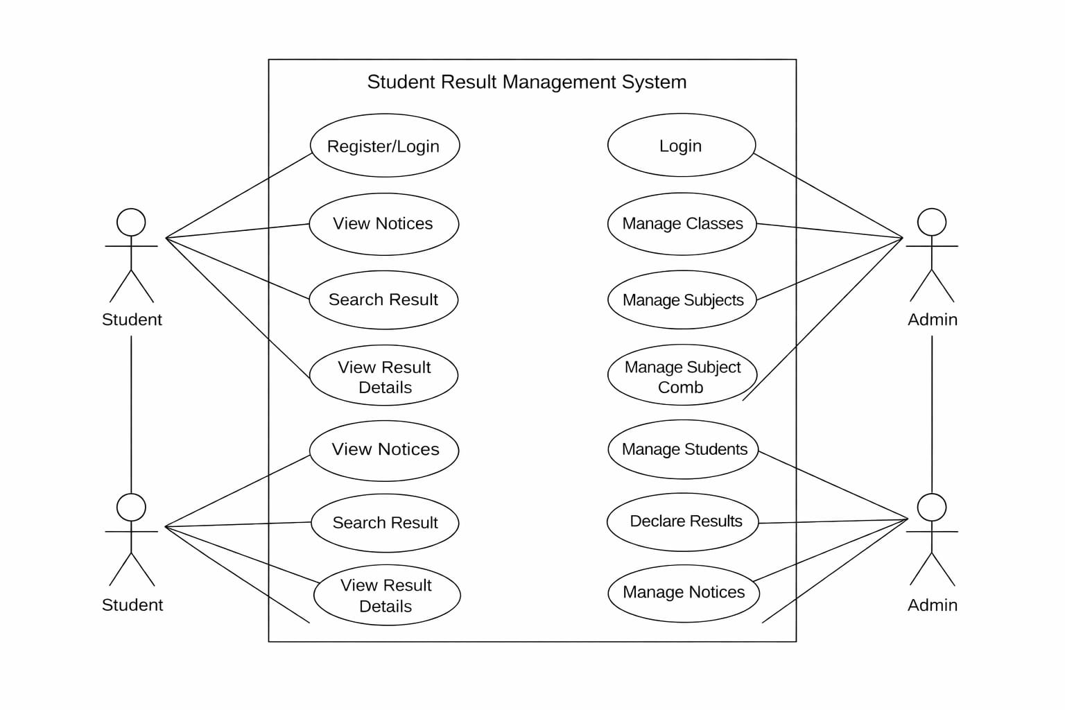

6.2 ER Diagram
The ER Diagram show’s how data entitie’s in the system are connected.
Main Entities and Attributes:
1.Admin: ‘id (PK), UserName, Password, updationDate’,
2.tblclasses: ‘id (PK), ClassName, ClassNameNumeric, Section, CreationDate, UpdationDate’,
3.tblsubjects: ‘id (PK), SubjectName, SubjectCode, Creationdate, UpdationDate’,
4. tblstudents: ‘Student Id (PK), StudentName, RollId, StudentEmail, Gender, DOB, ClassId (FK),RegDate, Status’,
5.tblsubjectcombination: ‘id (PK), ClassId (FK), SubjectId (FK), status, CreationDate, Updationdate’,
6.tblresult: id (PK), ‘StudentId (FK), ClassId (FK), SubjectId (FK), marks, PostingDate,UpdationDate’,
7.tblnotice: ‘id (PK), noticeTitle, noticeDetails, postingDateRelationships’.
- A Class can have many Student’s (one-to-many).
- A Class can have many Subject’s through tblsubjectcombination (many-to-many).
- A Student belongs to one Class (many-to-one).
- A Student can have many Result’s (one-to-many across subject’s).
- A Subject can be assigned to many Classe’s (many-to-many).
- An Admin manages all entities (no direct foreign keys shown in the schema).
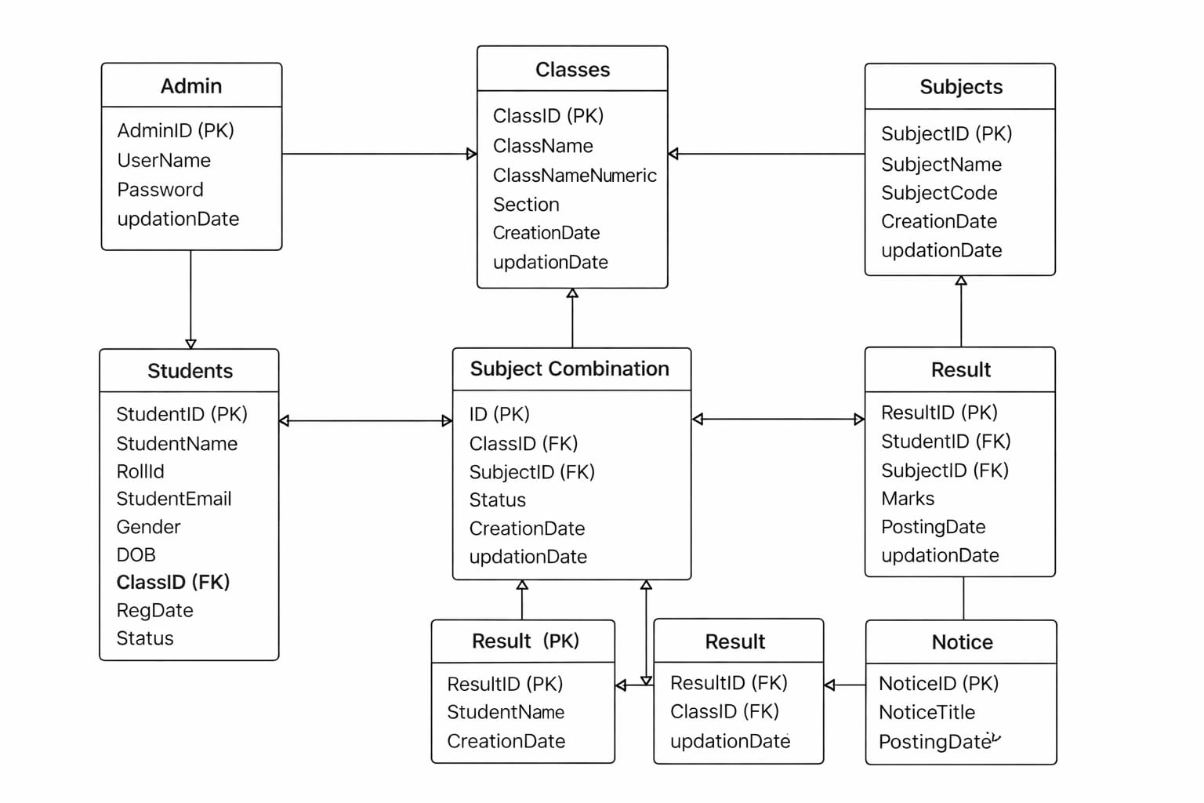

6.3 Data Flow Diagram (DFD)
DFD Level 0 (Context Diagram): Show’s the entire system as a single process with external entitie’s (Student, Admin).
- Student: Provides Roll ID and Class selection. Receive’s Result Details and Notice’s.
- Admin: Provide’s Login Credential’s, Class/Subject/Student/Result/Notice Data. Receives Dashboard Stat’s and confirmation message’s.

Level0 Diagram 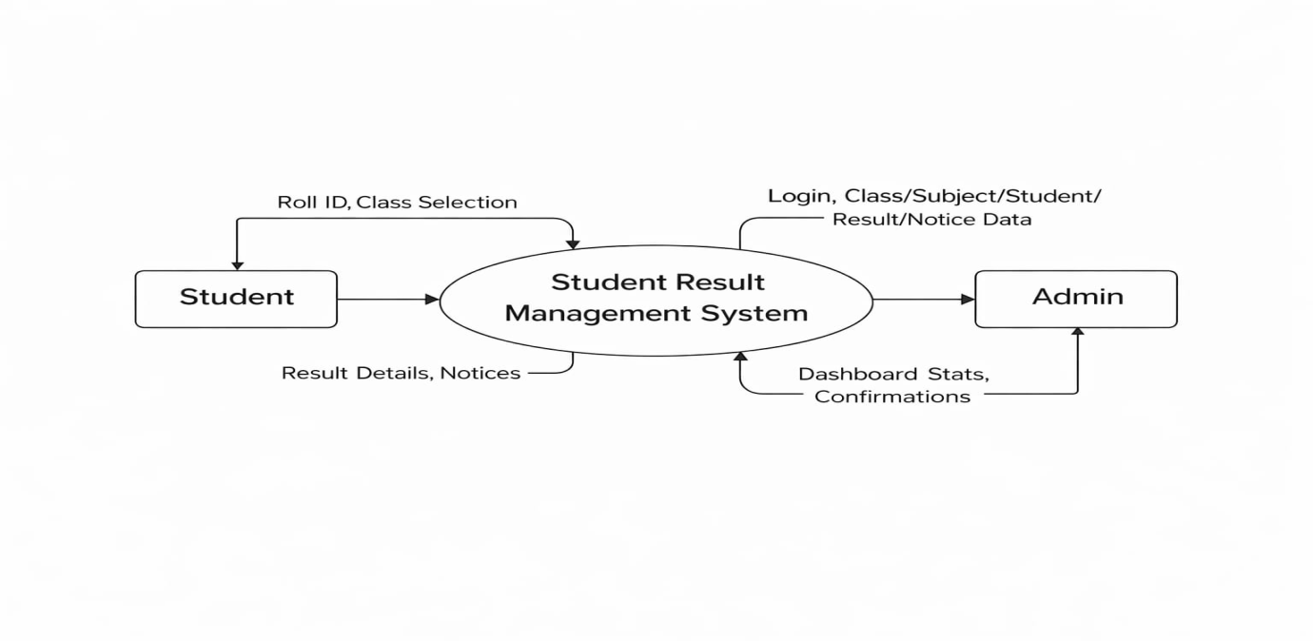
DFD Level 1: Breakdown of the system into major processe’s:
1.Student Result Process:
- Input: Roll ID, Class ID.
- Process: Validate input, query database for student info and result mark’s.
- Output: Display result mark sheet.
2.Admin Authentication Process:
- Input: Username, Password.
- Process: Verify against admin table, start session.
- Output: Access to admin panel or error message.
3.Master Data Management (Classe’s, Subject’s, Student’s):
- Input: CRUD operation’s from admin form’s.
- Process: Insert/Update/Delete records in respective tables (tblclasse’s, tblsubject’s, tblstudent’s).
- Output: Updated lists and confirmation message’s.

4.Subject Combination Management:
- Input: Class ID, Subject ID.
- Process: Insert into tblsubjectcombination. Activate/Deactivate by updating statu’s.
- Output: Updated combination list.
5.Result Declaration Process:
- Input: Student ID, Class ID, Subject-wise mark’s.
- Process: Insert multiple records into tblresult.
- Output: Success/error message.
6.Notice Management Process:
- Input: Notice Title, Details.
- Process: Insert into tblnotice or delete by ID.
- Output: Updated notice list on homepage.

Level1 Diagram

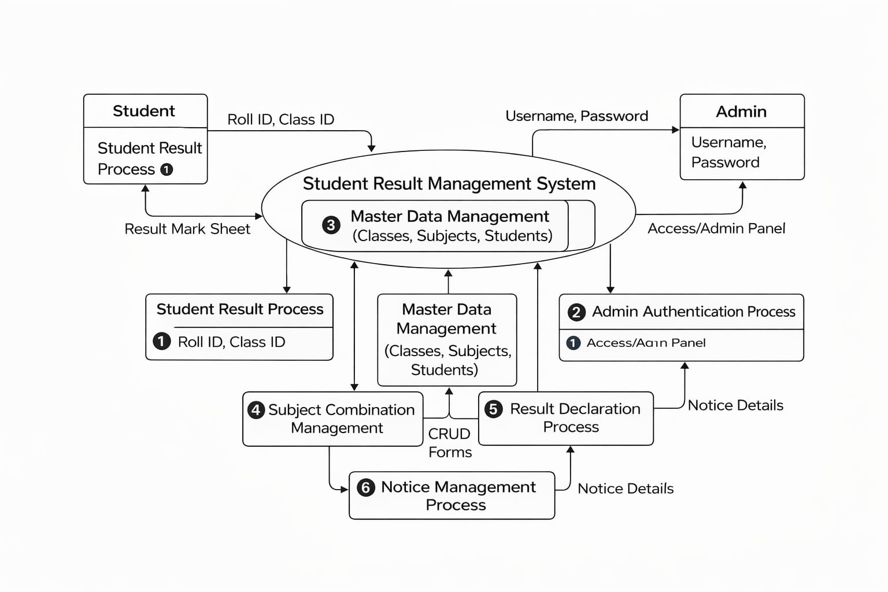

PROJECT PLANNING

“Project planning is the process of defining the scope, objectives, task’s, timelines, resources, and workflow required to successfully complete a project”. It ensures that all activitie’s are organized and coordinated so the project is completed on time, within budget, and meet’s the expected quality.

Key Components of Project Planning

- Project Objectives
  - Clearly define what the project aims to achieve.
  - Objective’s must be “Specific, Measurable, Achievable, Relevant, and Time-bound (SMART)”.

Project Scope
  - Identify project boundarie’s — what is included and what is not.
  - Helps avoid scopecreep (uncontrolledchange’s).

Work Break down Structure(WBS)
  - Break the entire project into smaller, manageable task’s.
  - Makes it easier to assign work and estimate time.

Project Schedule
  - Decide the timeline for each task.
  - Tools like Ganttchart’s, PERTchart’s, or timeline’s are often used.

Resource Planning
  - Identify required resource’s:
  - Human resource’s (teammember’s)
  - Hardware/software
  - Budget and material’s

Risk Management
  - Identify possible risk’s.
  - Prepare mitigation strategie’s to handle uncertaintie’s.

Communication Plan
  - Decide how information will be share damong team members.
  - Includes meeting schedule’s and reporting formats.

Quality Management Plan
  - Set quality standard’s and procedure’s.
  - Ensure project deliverable smeetthe expected criteria.

Budget Planning
  - Estimate total cost.
  - Allocate funds across different activitie’s.

GANTT CHART
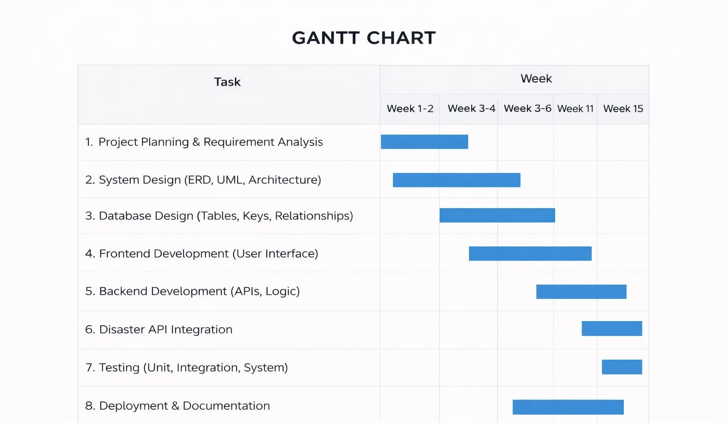

7.2 PERT CHART
A PERT (“Program Evaluation and Review Technique”) Chart is used to analyze project tasks, estimate timeline’s, and understand dependencie’s between activitie’s. It help’s identify the critical path, which determines the minimum time required to complete the project.

Activity ID | Activity Name | Depends On | Optimistic (O) | Most Likely (M) | Pessimistic (P) | Expected Time(TE)
A | Requirement Analysis | – | 1 week | 2 weeks | 3 weeks | 2.0 weeks
B | System Design | A | 1 week | 2 weeks | 3 weeks | 2.0 weeks
C | Database Design | B | 1 week | 2 weeks | 3 weeks | 2.0 weeks
D | Frontend Development | B | 2 weeks | 3 weeks | 4 weeks | 3.0 weeks
E | Backend Development | C | 2 weeks | 3 weeks | 4 weeks | 3.0 weeks
F | API Integration | E | 1 week | 2 weeks | 3 weeks | 2.0 weeks
G | Testing | D, F | 1 week | 2 weeks | 3 weeks | 2.0 weeks
H | Deployment & Documentation | G | 1 week | 2 weeks | 3 weeks | - weeks

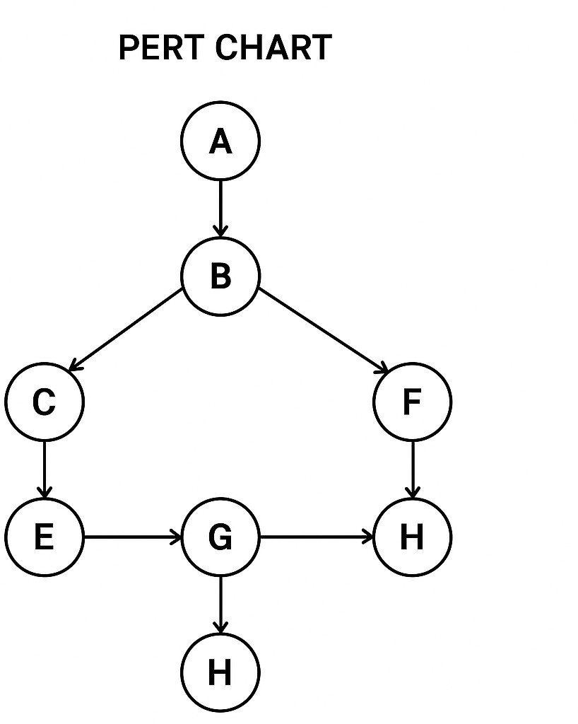

7.3 SDLC Phases (Waterfall Model)
The “Software Development LifeCycle” (SDLC) provides a structured approach for planning, designing, building, testing, and deploying software systems”. For the “STUDENT RESULT MANAGEMENT SYSTEM SDLC” ensures that development is systematic, efficient, and deliver’s a high-quality product. The major SDLC phases are described below:

Requirement Analysis

“This is the first and most important phase of “SDLC”. It involves gathering and understanding the requirements of the system from stakeholder’s”. For this project, requirements include real-time disaster alerts, emergency contact access, user registration, incident reporting, and admin management. Both functional and non-functional requirements are documented. This phase ensure’s the system meets user needs and solves real-world problem’s[4].

System Design

In this phase,the system architecture is created based on the requirement’s. System design includes:
  - Use Case Diagram
  - ER Diagram
  - Data Flow Diagram
  - Database schema

Implementation(Coding)

Developed the system using “PHP, MySQL, HTML, CSS (Bootstrap), and JavaScript/jQuery”. Implemented all module’s as described in the functional requirement’s[6].

Testing

In this phase,the complete system is tested to check for bugs, error’s, and usability issue’s. Different testing technique’s are performed:
  - Unit Testing
  - Integration Testing
  - System Testing
  - User Acceptance Testing (UAT)
  - Testing ensures the system delivers accurate alert’s, store’s data correctly, and functions smoothly under real-time condition’s.

Deployment

The system is designed to be deployed on a local server (XAMPP) or a web host. The srms.sql file is imported, and the PHP files are placed in the server's root directory.

Maintenance

After deployment, the system requires regular update’s, fixe’s, and improvement’s. Ongoing maintenance includes updating notice content, adding new classes/subject’s, and addressing any potential bugs or security issue’s. Maintenance activitie’s include:

  - Adding new feature’s
  - Fixing unexpected bug’s
  - Updating information

SDLCPHASE | Project Activity | Duration | Start | Finish
Task 1 | RequirementAnalysis | 10 | 02-02-2025 | 12-02-2025
Task 2 | Feasibility Study | 12 | 12-02-2025 | 24-02-2025
Task 3 | SystemDesign | 20 | 25-02-2025 | 16-03-2025
Task 4 | Documentation | 15 | 17-03-2025 | 02-04-2025
Task 5 | Programming | 20 | 03-04-2025 | 23-04-2025
Task 6 | Testing | 7 | 24-04-2025 | 01-05-2025

TECHNICAL DETAILS

This section describes the technologie’s, tools, and platform’s used to develop the Student Result Management System.

8.1 Frontend Technologies
The frontend is the user-facing part of the system, responsible for creating an interactive and responsive interface.
- HTML5 & CSS3: “Used for structuring and styling web page’s, ensuring semantic markup and consistent presentation”.
- Bootstrap 3.x: “A responsive CSS framework that provide’s a grid system, pre-built component’s (navbars, forms, buttons, panels, tables), and utility classe’s. It ensures the application work’s seamlessly across devices (desktops, tablets, smartphones)”.
- JavaScript (ES5/ES6): “Handle’s client-side logic such as dynamic form submission, AJAX requests for fetching students/subjects without page reload, and interactive UI element’s”.
- jQuery: “A fast and feature-rich JavaScript library used to simplify DOM manipulation, event handling, and AJAX calls (e.g., in get_student.php and add-result.php)”.
- Font Awesome: “Used for icon’s (e.g., dashboard icon’s, edit/delete button’s, navigation icons) to enhance visual appeal”.
Frontend Features:
- Responsive admin dashboard with collapsible sidebar.
- DataTable’s plugin for managing tabular data with search, sort, and pagination (used in manage-classe’s.php, manage-student’s.php, etc.).
- Toastr notification’s for user feedback (in dashboard.php).
- ICheck for styling radio button’s and checkboxe’s.

8.2 Backend Technologies
The backend handle’s server logic, database interaction’s, authentication, and session management.
- PHP (Hypertext Preprocessor): “The core server-side scripting language. It processes form data, interact’s with the ‘MySQL’ database using ‘PDO’ (PHP Data Objects), manages user sessions, and dynamically generates HTML content”.
- PDO: “Used for secure database connection’s and parameterized querie’s to prevent SQL injection”.
- Session Management: “PHP session’s (session_start()) are used to maintain admin login state across page’s”.
- Password Hashing: “MD5 hashing (though not the strongest, it's used in the provided code) is applied to admin password’s before storage and comparison”.
- MySQL: “The relational database management system used to store all application data (admin, students, classes, subjects, results, notices). ‘SQL’ queries are used for ‘CRUD’ operation’s”.
- Apache (via XAMPP/WAMP): “The web server that handles HTTP requests, serves PHP files, and processes the application logic”.

Backend Features:
- Modular code structure with include’s/config.php for database connection and common functions, includes/topbar.php, and includes/leftbar.php for reusable UI components.
- Server-side validation of form input’s[8].
- Dynamic AJAX endpoints (get_student.php) to fetch student’s and subject’s based on selected class without page reload.

8.3 Database
The database store’s all key information for the ‘SRMS’. The schema is defined in srms.sql.
Database Name: srms
Main Table’s and Structure:

Table Name | Description | Key Columns
admin | Stores admin credentials. | id (PK), UserName, Password (MD5 hash)
tbclasses | Stores class and section information. | id (PK), ClassName, ClassNameNumeric, Section
tblsubjects | Stores subject master data | id (PK), SubjectName, SubjectCode
tblstudents | Stores student personal and academic details. | StudentId (PK), StudentName, RollId, ClassId (FK), Status
tblsubjectcombination | Maps classes to subjects (many-to-many). | id (PK), ClassId (FK), SubjectId (FK), status (active/inactive)
tblresult | Stores marks for each student per subject. | id (PK), StudentId (FK), ClassId (FK), SubjectId (FK), marks
tblnotice | Stores notices for public display. | id (PK), noticeTitle, noticeDetail’s, postingDate

TESTING AND IMPLEMENTATION

9.1 Test Plan
“The testing phase ensures that all components of the “Student Result Management System” work correctly, efficiently, and securely”.
- Unit Testing:
- Tested individual function’s: adding a class, adding a subject, inserting a student, declaring a result for one subject.
- Verified input validation (e.g., mark’s must be numeric, required fields cannot be empty).
- Integration Testing:
- Verified interaction between module’s: class creation → subject combination → student assignment → result declaration → result display.
- Tested the workflow: admin login → add notice → view notice on public homepage.
- Verified AJAX calls: selecting a class populate’s the student dropdown and subject list correctly.
- System Testing:
- Conducted end-to-end workflow testing: student result search → display correct marksheet.
- Tested admin panel security: direct access to admin page’s without login redirect’s to index.php.
- Tested result declaration with duplicate prevention (student+class combination cannot be redeclared without edit).
- Performance Testing:
- Tested page load times with a moderate dataset (approx. 50 student’s, 10 subject’s, 5 classe’s).
- Verified DataTable’s performance for searching and sorting large list’s.
- Security Testing:
- Verified that password’s are hashed (MD5) before storage.
- Checked for SQL injection vulnerabilities by using special character’s in input field’s (PDO parameterized querie’s mitigate this).
- Ensured session variables ($_SESSION['alogin']) are checked on every admin page.
- User Acceptance Testing (UAT):
- Simulated admin user adding a new student and declaring result’s.
- Simulated student user searching for result’s using a valid roll ID and class.

.

9.2 Results and Analysis
Test Area | Expected Output | Actual Result | Status
Admin Login | Successful login redirect’s to dashboard; invalid credentials show error. | Work’s as expected. | Pass
Add Class | New class appear’s in manage classes list. | Work’s as expected. | Pass
Add Subject | New subject appear’s in manage subject’s list. | Work’s as expected. | Pass
Subject Combination | Class-subject mapping saved; appear’s in combination list. | Work’s as expected. | Pass
Add Student | New student appear’s in manage student’s list with correct class. | Work’s as expected. | Pass
Declare Result | Marks saved; success message shown; result searchable by student. | Work’s as expected. | Pass
Duplicate Result Declaration | System prevent’s declaring result again for same student/class. | Work’s as expected (via get_student.php check). | Pass
Edit Result | Marks updated; change’s reflected in student result view. | Work’s as expected. | Pass
Student Result Search | Valid Roll ID + Class display’s marksheet; invalid shows error. | Work’s as expected. | Pass
Public Notice’s | Notices added by admin appear on homepage. | Work’s as expected. | Pass
Unauthorized Admin Acces’s | Accessing admin page without login redirects to index.php. | Work’s as expected (session check). | Pass

Performance Analysis:
- Average page load time: 1.5–2.5 second’s on a local XAMPP server.
- Database query response time: < 500ms for most SELECT querie’s.
- DataTable initialization on table’s with 100+ rows: < 1 second.
Error & Bug Summary:
- Minor CSS alignment issue’s in the result search form (fixed).
- The edit-result.php had a potential logical issue in the UPDATE query loop (verified and corrected)[1].
- Input validation for mark’s range (0-100) was not initially present; added client-side validation.
Conclusion:
The system performed successfully under all test case’s. All module’s functioned as intended, showing strong stability, accuracy, and reliability. The project is ready for deployment.

LIMITATIONS AND FUTURE SCOPE

10.1 Current Limitations
Despite successfully implementing the “Student Result Management System”, several limitation’s exist:
- No Student Login/Profile: Student’s cannot log in to view their profile, result history, or download mark sheet’s. They can only search by roll number.
- No Parent/Guardian Access: Parent’s cannot access result’s or notices directly; they must use the student's roll number.
- No PDF Generation: Result’s cannot be downloaded as a PDF mark sheet; user’s must print the web page.
- Basic Password Security: Admin passwords are hashed using MD5, which is considered weak by modern standard’s. No salting is applied.
- No Role-Based Access Control for Admin: Only one type of admin exist’s. There is no distinction between super admin and data entry operator[3].
- No Automated Result Calculation: Total and percentage are calculated at display time in result.php, not stored in the database. This require’s re-querying all subject mark’s each time.
- No Graphical Reports/Charts: No analytic’s or visual representation of class performance, subject-wise average’s, or grade distribution.
- No Email/SMS Notifications: Student’s are not notified via email or SMS when result’s are declared.
- Limited Backup/Recovery: No built-in database backup or restore functionality.

10.2 Potential Enhancements
Several improvements can significantly enhance the system's functionality and user experience:
- Student and Parent Portal: “Create login account’s for student’s and parents to view results, attendance, notice’s, and profile information”.
- PDF Mark Sheet Generation: “Integrate a PDF library (e.g., “TCPDF”, “FPDF”) to generate downloadable/printable mark sheet’s”.
- Improved Security: Replace MD5 hashing with password_hash() and password_verify(). Implement CSRF protection.
- Email/SMS Integration: Send automatic email or SMS notification’s to student’s/parent’s when result’s are declared or when a new notice is posted.
- Advanced Result Features: Store calculated total’s and percentage’s, introduce grade/GPA systems, and allow result filtering by exam type (e.g., Mid-term, Final).
- Analytics Dashboard: Add chart’s and graph’s (using Chart.js or similar) to visualize performance trends, subject-wise average’s, and top performer’s.
- Multiple Exam Support: Extend the result schema to include an ExamId or ExamType field so that multiple exams per student/class can be managed.
- Online Fee Management: Integrate a fee collection module for online payment’s and tracking.
- RESTful API: Develop an API for mobile app integration, allowing student’s to fetch result’s via a mobile application.
- Data Import/Export: “Allow bulk import of student’s via CSV/Excel and export of result data”.

CONCLUSION

The “Student Result Management System” (SRMS) successfully addresse’s the key challenge’s of traditional result management method’s by providing a centralized, efficient, and user-friendly web-based platform. The system enable’s educational institution’s to manage student data, class information, subject master data, subject combinations, and student result’s with ease and accuracy.
The project achieved its primary objective’s:
- Streamlined administrative task’s through dedicated module’s for classes, subject’s, student’s, and result’s.
- Provided instant, secure online access to result’s for student’s using only their roll number and class selection.
- Enhanced communication via a dynamic notice board on the public homepage.
- Ensured data integrity and security through session management, input validation, and parameterized database querie’s.
The system was developed using reliable and widely-adopted technologie’s: “PHP” for backend logic, ‘MySQL’ for database storage, and ‘Bootstrap’ for a responsive frontend. Extensive testing confirmed that all module’s function correctly, the system is performant, and access control’s are effective[9].
While there are limitation’s, such as the lack of a student login portal and “PDF” generation, “the architecture is modular and extensible, “allowing for future enhancements like email notification’s, advanced analytic’s, and “API” development for mobile apps. Overall, the ‘SRMS’ provide’s a solid foundation for modernizing academic result management, saving time and resource’s while improving accessibility and transparency for all stakeholder’s.
.

- CODING
DATABASE:
Srms.sql

-- phpMyAdmin SQL Dump
-- version 5.2.1
-- https://www.phpmyadmin.net/
--
-- Host: 127.0.0.1
-- Generation Time: Jun 07, 2024 at 07:31 AM
-- Server version: 10.4.28-MariaDB
-- PHP Version: 8.2.4

SET SQL_MODE = "NO_AUTO_VALUE_ON_ZERO";
START TRANSACTION;
SET time_zone = "+00:00";

/*!40101 SET @OLD_CHARACTER_SET_CLIENT=@@CHARACTER_SET_CLIENT */;
/*!40101 SET @OLD_CHARACTER_SET_RESULTS=@@CHARACTER_SET_RESULTS */;
/*!40101 SET @OLD_COLLATION_CONNECTION=@@COLLATION_CONNECTION */;
/*!40101 SET NAMES utf8mb4 */;

--
-- Database: `srms`
--

-- --------------------------------------------------------

--
-- Table structure for table `admin`
--

CREATE TABLE `admin` (
`id` int(11) NOT NULL,
`UserName` varchar(100) DEFAULT NULL,
`Password` varchar(100) DEFAULT NULL,
`updationDate` timestamp NULL DEFAULT NULL
) ENGINE=InnoDB DEFAULT CHARSET=latin1 COLLATE=latin1_swedish_ci;

--
-- Dumping data for table `admin`
--

INSERT INTO `admin` (`id`, `UserName`, `Password`, `updationDate`) VALUES
(1, 'admin', 'f925916e2754e5e03f75dd58a5733251', '2024-03-10 10:30:57');

-- --------------------------------------------------------

--
-- Table structure for table `tblclasses`
--

CREATE TABLE `tblclasses` (
`id` int(11) NOT NULL,
`ClassName` varchar(80) DEFAULT NULL,
`ClassNameNumeric` int(4) DEFAULT NULL,
`Section` varchar(5) DEFAULT NULL,
`CreationDate` timestamp NULL DEFAULT current_timestamp(),
`UpdationDate` timestamp NULL DEFAULT NULL
) ENGINE=InnoDB DEFAULT CHARSET=latin1 COLLATE=latin1_swedish_ci;

--
-- Dumping data for table `tblclasses`
--

INSERT INTO `tblclasses` (`id`, `ClassName`, `ClassNameNumeric`, `Section`, `CreationDate`, `UpdationDate`) VALUES
(1, 'First', 1, 'C', '2024-04-25 10:30:57', '2022-01-01 10:30:57'),
(2, 'Second', 2, 'A', '2024-04-25 10:30:57', '2022-01-01 10:30:57'),
(4, 'Fourth', 4, 'C', '2024-04-25 10:30:57', '2022-01-01 10:30:57'),
(5, 'Sixth', 6, 'A', '2024-04-25 10:30:57', '2022-01-01 10:30:57'),
(6, 'Sixth', 6, 'B', '2024-04-25 10:30:57', '2022-01-01 10:30:57'),
(7, 'Seventh', 7, 'B', '2024-04-25 10:30:57', '2022-01-01 10:30:57'),
(8, 'Eight', 8, 'A', '2024-04-25 10:30:57', '2022-01-01 10:30:57'),
(9, 'Tenth', 10, 'A', '2024-04-25 10:30:57', NULL);

-- --------------------------------------------------------

--
-- Table structure for table `tblnotice`
--

CREATE TABLE `tblnotice` (
`id` int(11) NOT NULL,
`noticeTitle` varchar(255) DEFAULT NULL,
`noticeDetails` mediumtext DEFAULT NULL,
`postingDate` timestamp NULL DEFAULT current_timestamp()
) ENGINE=InnoDB DEFAULT CHARSET=utf8mb4 COLLATE=utf8mb4_general_ci;

--
-- Dumping data for table `tblnotice`
--

INSERT INTO `tblnotice` (`id`, `noticeTitle`, `noticeDetails`, `postingDate`) VALUES
(2, 'Notice regarding result Delearation', 'Lorem ipsum dolor sit amet, consectetur adipiscing elit, sed do eiusmod tempor incididunt ut labore et dolore magna aliqua. Adipiscing elit ut aliquam purus. Vel risus commodo viverra maecenas. Et netus et malesuada fames ac turpis egestas sed. Cursus eget nunc scelerisque viverra mauris in aliquam sem fringilla. Ornare arcu odio ut sem nulla pharetra diam. Vel pharetra vel turpis nunc eget lorem dolor sed. Velit ut tortor pretium viverra suspendisse. In ornare quam viverra orci sagittis eu. Viverra tellus in hac habitasse. Donec massa sapien faucibus et molestie. Libero justo laoreet sit amet cursus sit amet dictum. Dignissim diam quis enim lobortis scelerisque fermentum dui.\r\n\r\nEget nulla facilisi etiam dignissim. Quisque non tellus orci ac. Amet cursus sit amet dictum sit amet justo donec. Interdum velit euismod in pellentesque massa. Condimentum lacinia quis vel eros donec ac odio. Magna eget est lorem ipsum dolor. Bibendum at varius vel pharetra vel turpis nunc eget lorem. Pellentesque adipiscing commodo elit at imperdiet dui accumsan sit amet. Maecenas accumsan lacus vel facilisis volutpat est velit egestas dui. Massa tincidunt dui ut ornare lectus sit amet est placerat. Nisi quis eleifend quam adipiscing vitae.', '2024-05-01 14:34:58'),
(3, 'Test Notice', 'This is for testing purposes only. This is for testing purposes only. This is for testing purposes only. This is for testing purposes only. This is for testing purposes only. This is for testing purposes only. This is for testing purposes only. This is for testing purposes only. This is for testing purposes only. This is for testing purposes only. This is for testing purposes only. This is for testing purposes only. This is for testing purposes only. This is for testing purposes only. This is for testing purposes only. This is for testing purposes only. This is for testing purposes only. ', '2024-05-02 14:48:32');

-- --------------------------------------------------------

--
-- Table structure for table `tblresult`
--

CREATE TABLE `tblresult` (
`id` int(11) NOT NULL,
`StudentId` int(11) DEFAULT NULL,
`ClassId` int(11) DEFAULT NULL,
`SubjectId` int(11) DEFAULT NULL,
`marks` int(11) DEFAULT NULL,
`PostingDate` timestamp NULL DEFAULT current_timestamp(),
`UpdationDate` timestamp NULL DEFAULT NULL
) ENGINE=InnoDB DEFAULT CHARSET=latin1 COLLATE=latin1_swedish_ci;

--
-- Dumping data for table `tblresult`
--

INSERT INTO `tblresult` (`id`, `StudentId`, `ClassId`, `SubjectId`, `marks`, `PostingDate`, `UpdationDate`) VALUES
(2, 1, 1, 2, 100, '2024-05-10 10:30:57', NULL),
(3, 1, 1, 1, 80, '2024-05-10 10:30:57', NULL),
(4, 1, 1, 5, 78, '2024-05-10 10:30:57', NULL),
(5, 1, 1, 4, 60, '2024-05-10 10:30:57', NULL),
(6, 2, 4, 2, 90, '2024-05-10 10:30:57', NULL),
(7, 2, 4, 1, 75, '2024-05-10 10:30:57', NULL),
(8, 2, 4, 5, 56, '2024-05-10 10:30:57', NULL),
(9, 2, 4, 4, 80, '2024-05-10 10:30:57', NULL),
(10, 4, 7, 2, 54, '2024-05-10 10:30:57', NULL),
(11, 4, 7, 1, 85, '2024-05-10 10:30:57', NULL),
(12, 4, 7, 5, 55, '2024-05-10 10:30:57', NULL),
(13, 4, 7, 7, 65, '2024-05-10 10:30:57', NULL),
(14, 5, 8, 2, 75, '2024-05-10 10:30:57', NULL),
(15, 5, 8, 1, 56, '2024-05-10 10:30:57', NULL),
(16, 5, 8, 5, 52, '2024-05-10 10:30:57', NULL),
(17, 5, 8, 4, 80, '2024-05-10 10:30:57', NULL),
(18, 6, 9, 7, 80, '2024-05-20 15:20:18', NULL),
(19, 6, 9, 7, 70, '2024-05-20 15:20:18', NULL),
(20, 6, 9, 2, 90, '2024-05-20 15:20:18', NULL),
(21, 6, 9, 1, 60, '2024-05-20 15:20:18', NULL);

-- --------------------------------------------------------

--
-- Table structure for table `tblstudents`
--

CREATE TABLE `tblstudents` (
`StudentId` int(11) NOT NULL,
`StudentName` varchar(100) DEFAULT NULL,
`RollId` varchar(100) DEFAULT NULL,
`StudentEmail` varchar(100) DEFAULT NULL,
`Gender` varchar(10) DEFAULT NULL,
`DOB` varchar(100) DEFAULT NULL,
`ClassId` int(11) DEFAULT NULL,
`RegDate` timestamp NULL DEFAULT current_timestamp(),
`UpdationDate` timestamp NULL DEFAULT NULL,
`Status` int(1) DEFAULT NULL
) ENGINE=InnoDB DEFAULT CHARSET=latin1 COLLATE=latin1_swedish_ci;

--
-- Dumping data for table `tblstudents`
--

INSERT INTO `tblstudents` (`StudentId`, `StudentName`, `RollId`, `StudentEmail`, `Gender`, `DOB`, `ClassId`, `RegDate`, `UpdationDate`, `Status`) VALUES
(1, 'Sarita', '46456', 'info@phpgurukul.com', 'Female', '1995-03-03', 1, '2024-04-20 10:30:57', NULL, 1),
(2, 'Anuj kumar', '10861', 'anuj@gmail.co', 'Male', '1995-02-02', 4, '2024-04-24 10:30:57', NULL, 0),
(3, 'amit kumar', '2626', 'amit@gmail.com', 'Male', '2014-08-06', 6, '2024-04-22 10:30:57', NULL, 1),
(4, 'rahul kumar', '990', 'rahul01@gmail.com', 'Male', '2001-02-03', 7, '2024-04-24 10:30:57', NULL, 1),
(5, 'sanjeev singh', '122', 'sanjeev01@gmail.com', 'Male', '2002-02-03', 8, '2024-04-25 10:30:57', NULL, 1),
(6, 'Shiv Gupta', '12345', 'shiv34534@gmail.com', 'Male', '2007-01-12', 9, '2024-05-01 15:19:40', NULL, 1);

-- --------------------------------------------------------

--
-- Table structure for table `tblsubjectcombination`
--

CREATE TABLE `tblsubjectcombination` (
`id` int(11) NOT NULL,
`ClassId` int(11) DEFAULT NULL,
`SubjectId` int(11) DEFAULT NULL,
`status` int(1) DEFAULT NULL,
`CreationDate` timestamp NULL DEFAULT current_timestamp(),
`Updationdate` timestamp NULL DEFAULT NULL ON UPDATE current_timestamp()
) ENGINE=InnoDB DEFAULT CHARSET=latin1 COLLATE=latin1_swedish_ci;

--
-- Dumping data for table `tblsubjectcombination`
--

INSERT INTO `tblsubjectcombination` (`id`, `ClassId`, `SubjectId`, `status`, `CreationDate`, `Updationdate`) VALUES
(3, 2, 5, 0, '2024-05-01 10:30:57', '2024-06-07 05:25:49'),
(4, 1, 2, 1, '2024-05-01 10:30:57', '2024-06-07 04:28:00'),
(5, 1, 4, 1, '2024-05-01 10:30:57', '2024-06-07 04:28:00'),
(6, 1, 5, 1, '2024-05-01 10:30:57', '2024-06-07 04:28:00'),
(8, 4, 4, 1, '2024-05-01 10:30:57', '2024-06-07 04:28:00'),
(10, 4, 1, 1, '2024-05-01 10:30:57', '2024-06-07 04:28:00'),
(12, 4, 2, 1, '2024-05-01 10:30:57', '2024-06-07 04:28:00'),
(13, 4, 5, 1, '2024-05-01 10:30:57', '2024-06-07 04:28:00'),
(14, 6, 1, 1, '2024-05-01 10:30:57', '2024-06-07 04:28:00'),
(15, 6, 2, 1, '2024-05-01 10:30:57', '2024-06-07 04:28:00'),
(16, 6, 4, 1, '2024-05-01 10:30:57', '2024-06-07 04:28:00'),
(17, 6, 6, 1, '2024-05-01 10:30:57', '2024-06-07 04:28:00'),
(18, 7, 1, 1, '2024-05-01 10:30:57', '2024-06-07 04:28:00'),
(19, 7, 7, 1, '2024-05-01 10:30:57', '2024-06-07 04:28:00'),
(20, 7, 2, 1, '2024-05-01 10:30:57', '2024-06-07 04:28:00'),
(21, 7, 6, 1, '2024-05-01 10:30:57', '2024-06-07 04:28:00'),
(22, 7, 5, 0, '2024-05-01 10:30:57', '2024-06-07 04:28:00'),
(23, 8, 1, 1, '2024-05-01 10:30:57', '2024-06-07 04:28:00'),
(24, 8, 2, 1, '2024-05-01 10:30:57', '2024-06-07 04:28:00'),
(25, 8, 4, 1, '2024-05-01 10:30:57', '2024-06-07 04:28:00'),
(26, 8, 6, 1, '2024-05-01 10:30:57', '2024-06-07 04:28:00'),
(27, 8, 5, 0, '2024-05-01 10:30:57', '2024-06-07 04:28:00'),
(28, 9, 1, 1, '2024-05-01 10:30:57', '2024-06-07 04:28:00'),
(29, 9, 2, 1, '2024-05-01 10:30:57', '2024-06-07 04:28:00'),
(30, 9, 7, 1, '2024-05-01 10:30:57', '2024-06-07 04:28:00');

-- --------------------------------------------------------

--
-- Table structure for table `tblsubjects`
--

CREATE TABLE `tblsubjects` (
`id` int(11) NOT NULL,
`SubjectName` varchar(100) NOT NULL,
`SubjectCode` varchar(100) DEFAULT NULL,
`Creationdate` timestamp NULL DEFAULT current_timestamp(),
`UpdationDate` timestamp NULL DEFAULT NULL
) ENGINE=InnoDB DEFAULT CHARSET=latin1 COLLATE=latin1_swedish_ci;

--
-- Dumping data for table `tblsubjects`
--

INSERT INTO `tblsubjects` (`id`, `SubjectName`, `SubjectCode`, `Creationdate`, `UpdationDate`) VALUES
(1, 'Maths', 'MTH01', '2024-04-25 10:30:57', NULL),
(2, 'English', 'ENG11', '2024-04-25 10:30:57', NULL),
(4, 'Science', 'SC1', '2024-04-25 10:30:57', NULL),
(5, 'Music', 'MS', '2024-04-25 10:30:57', NULL),
(6, 'Social Studies', 'SS08', '2024-04-25 10:30:57', NULL),

(7, 'Physics', 'PH03', '2024-04-25 10:30:57', NULL),
(8, 'Chemistry', 'CH65', '2024-04-25 10:30:57', NULL);

--
-- Indexes for dumped tables
--

--
-- Indexes for table `admin`
--
ALTER TABLE `admin`
ADD PRIMARY KEY (`id`);

--
-- Indexes for table `tblclasses`
--
ALTER TABLE `tblclasses`
ADD PRIMARY KEY (`id`);

--
-- Indexes for table `tblnotice`
--
ALTER TABLE `tblnotice`
ADD PRIMARY KEY (`id`);

--
-- Indexes for table `tblresult`
--
ALTER TABLE `tblresult`
ADD PRIMARY KEY (`id`);

--
-- Indexes for table `tblstudents`
--
ALTER TABLE `tblstudents`
ADD PRIMARY KEY (`StudentId`);

--
-- Indexes for table `tblsubjectcombination`
--
ALTER TABLE `tblsubjectcombination`
ADD PRIMARY KEY (`id`);

--
-- Indexes for table `tblsubjects`
--
ALTER TABLE `tblsubjects`
ADD PRIMARY KEY (`id`);

--
-- AUTO_INCREMENT for dumped tables
--

--
-- AUTO_INCREMENT for table `admin`
--
ALTER TABLE `admin`
MODIFY `id` int(11) NOT NULL AUTO_INCREMENT, AUTO_INCREMENT=2;

--
-- AUTO_INCREMENT for table `tblclasses`
--
ALTER TABLE `tblclasses`
MODIFY `id` int(11) NOT NULL AUTO_INCREMENT, AUTO_INCREMENT=11;

--
-- AUTO_INCREMENT for table `tblnotice`
--
ALTER TABLE `tblnotice`
MODIFY `id` int(11) NOT NULL AUTO_INCREMENT, AUTO_INCREMENT=6;
--
-- AUTO_INCREMENT for table `tblresult`
--
ALTER TABLE `tblresult`
MODIFY `id` int(11) NOT NULL AUTO_INCREMENT, AUTO_INCREMENT=22;

--
-- AUTO_INCREMENT for table `tblstudents`
--
ALTER TABLE `tblstudents`
MODIFY `StudentId` int(11) NOT NULL AUTO_INCREMENT, AUTO_INCREMENT=7;

--
-- AUTO_INCREMENT for table `tblsubjectcombination`
--
ALTER TABLE `tblsubjectcombination`
MODIFY `id` int(11) NOT NULL AUTO_INCREMENT, AUTO_INCREMENT=32;
--
-- AUTO_INCREMENT for table `tblsubjects`
--
ALTER TABLE `tblsubjects`
MODIFY `id` int(11) NOT NULL AUTO_INCREMENT, AUTO_INCREMENT=12;
COMMIT;

/*!40101 SET CHARACTER_SET_CLIENT=@OLD_CHARACTER_SET_CLIENT */;
/*!40101 SET CHARACTER_SET_RESULTS=@OLD_CHARACTER_SET_RESULTS */;
/*!40101 SET COLLATION_CONNECTION=@OLD_COLLATION_CONNECTION */;

admin-login.php
<?php
session_start();
error_reporting(0);
include('includes/config.php');
if($_SESSION['alogin']!=''){
$_SESSION['alogin']='';
}
if(isset($_POST['login']))
{
$uname=$_POST['username'];
$password=md5($_POST['password']);
$sql ="SELECT UserName,Password FROM admin WHERE UserName=:uname and Password=:password";
$query= $dbh -> prepare($sql);
$query-> bindParam(':uname', $uname, PDO::PARAM_STR);
$query-> bindParam(':password', $password, PDO::PARAM_STR);
$query-> execute();
$results=$query->fetchAll(PDO::FETCH_OBJ);
if($query->rowCount() > 0)
{
$_SESSION['alogin']=$_POST['username'];
echo "<script type='text/javascript'> document.location = 'dashboard.php'; </script>";
} else {
echo "<script>alert('Invalid Details');</script>";
}
}
?>
<!DOCTYPE html>
<html lang="en">
<head>
<meta charset="utf-8">
<meta http-equiv="X-UA-Compatible" content="IE=edge">
<meta name="viewport" content="width=device-width, initial-scale=1">
<title>Admin Login</title>
<link rel="stylesheet" href="css/bootstrap.min.css" media="screen" >
<link rel="stylesheet" href="css/font-awesome.min.css" media="screen" >
<link rel="stylesheet" href="css/animate-css/animate.min.css" media="screen" >
<link rel="stylesheet" href="css/prism/prism.css" media="screen" >
<link rel="stylesheet" href="css/main.css" media="screen" >
<script src="js/modernizr/modernizr.min.js"></script>
</head>
<body class="">
<div class="main-wrapper">
<div class="">
<div class="row">
<h1 align="center">Student Result Management System</h1>
<div class="col-lg-3"></div>
<div class="col-lg-6">
<section class="section">
<div class="row mt-40">
<div class="col-md-10 col-md-offset-1 pt-50">
<div class="row mt-30 ">
<div class="col-md-11">
<div class="panel">
<div class="panel-heading">
<div class="panel-title text-center">
<h4>Admin Login</h4>
</div>
</div>
<div class="panel-body p-20">
<form class="form-horizontal" method="post">
<div class="form-group">
<label for="inputEmail3" class="col-sm-2 control-label">Username</label>
<div class="col-sm-10">
<input type="text" name="username" class="form-control" id="inputEmail3" placeholder="UserName">

</div>
</div>
<div class="form-group">
<label for="inputPassword3" class="col-sm-2 control-label">Password</label>
<div class="col-sm-10">
<input type="password" name="password" class="form-control" id="inputPassword3" placeholder="Password">
</div>
</div>
<div class="form-group mt-20">
<div class="col-sm-offset-2 col-sm-10">
<button type="submit" name="login" class="btn btn-success btn-labeled pull-right">Sign in<span class="btn-label btn-label-right"><i class="fa fa-check"></i></span></button>
</div>
</div>
</form>
</div>
</div>
<p class="text-muted text-center"><small>Student Result Management System</small></p>
</div>
</div>
</div>
</div>
</section>
</div>
</div>
</div>
</div>
<script src="js/jquery/jquery-2.2.4.min.js"></script>
<script src="js/jquery-ui/jquery-ui.min.js"></script>
<script src="js/bootstrap/bootstrap.min.js"></script>
<script src="js/pace/pace.min.js"></script>
<script src="js/lobipanel/lobipanel.min.js"></script>
<script src="js/iscroll/iscroll.js"></script>
<script src="js/main.js"></script>
</body>
</html>

Dashboard.php
<?php
session_start();
error_reporting(0);
include('includes/config.php');
if(strlen($_SESSION['alogin'])=="")
{ header("Location: index.php"); }else{
?>
<!DOCTYPE html>
<html lang="en">
<head>
<meta charset="utf-8">
<meta http-equiv="X-UA-Compatible" content="IE=edge">
<meta name="viewport" content="width=device-width, initial-scale=1">
<title>Student Result Management System | Dashboard</title>
<link rel="stylesheet" href="css/bootstrap.min.css" media="screen" >
<link rel="stylesheet" href="css/font-awesome.min.css" media="screen" >
<link rel="stylesheet" href="css/animate-css/animate.min.css" media="screen" >
<link rel="stylesheet" href="css/lobipanel/lobipanel.min.css" media="screen" >
<link rel="stylesheet" href="css/toastr/toastr.min.css" media="screen" >

<link rel="stylesheet" href="css/icheck/skins/line/blue.css" >
<link rel="stylesheet" href="css/icheck/skins/line/red.css" >
<link rel="stylesheet" href="css/icheck/skins/line/green.css" >
<link rel="stylesheet" href="css/main.css" media="screen" >
<script src="js/modernizr/modernizr.min.js"></script>
</head>
<body class="top-navbar-fixed">
<div class="main-wrapper">
<?php include('includes/topbar.php');?>
<div class="content-wrapper">
<div class="content-container">
<?php include('includes/leftbar.php');?>
<div class="main-page">
<div class="container-fluid">
<div class="row page-title-div">
<div class="col-sm-6">
<h2 class="title">Dashboard</h2>
</div>
</div>
</div>
<section class="section">
<div class="container-fluid">
<div class="row">
<div class="col-lg-6 col-md-6 col-sm-6 col-xs-12">
<a class="dashboard-stat bg-primary" href="manage-students.php">
<?php
$sql1 ="SELECT StudentId from tblstudents ";
$query1 = $dbh -> prepare($sql1);
$query1->execute();
$totalstudents=$query1->rowCount();
?>
<span class="number counter"><?php echo htmlentities($totalstudents);?></span>
<span class="name">Regd Users</span>
<span class="bg-icon"><i class="fa fa-users"></i></span>
</a>
</div>
<div class="col-lg-6 col-md-6 col-sm-6 col-xs-12">
<a class="dashboard-stat bg-danger" href="manage-subjects.php">
<?php
$sql ="SELECT id from tblsubjects ";
$query = $dbh -> prepare($sql);
$query->execute();
$totalsubjects=$query->rowCount();
?>
<span class="number counter"><?php echo htmlentities($totalsubjects);?></span>
<span class="name">Subjects Listed</span>
<span class="bg-icon"><i class="fa fa-ticket"></i></span>
</a>
</div>
<div class="col-lg-6 col-md-6 col-sm-6 col-xs-12" style="margin-top:1%;">
<a class="dashboard-stat bg-warning" href="manage-classes.php">
<?php
$sql2 ="SELECT id from tblclasses ";
$query2 = $dbh -> prepare($sql2);
$query2->execute();
$totalclasses=$query2->rowCount();
?>
<span class="number counter"><?php echo htmlentities($totalclasses);?></span>
<span class="name">Total classes listed</span>
<span class="bg-icon"><i class="fa fa-bank"></i></span>
</a>
</div>
<div class="col-lg-6 col-md-6 col-sm-6 col-xs-12" style="margin-top:1%">
<a class="dashboard-stat bg-success" href="manage-results.php">

<?php
$sql3="SELECT distinct StudentId from tblresult ";

$query3 = $dbh -> prepare($sql3);
$query3->execute();
$totalresults=$query3->rowCount();
?>
<span class="number counter"><?php echo htmlentities($totalresults);?></span>
<span class="name">Results Declared</span>
<span class="bg-icon"><i class="fa fa-file-text"></i></span>
</a>
</div>
</div>
</div>
</section>
</div>
</div>
</div>
</div>
<script src="js/jquery/jquery-2.2.4.min.js"></script>
<script src="js/jquery-ui/jquery-ui.min.js"></script>
<script src="js/bootstrap/bootstrap.min.js"></script>
<script src="js/pace/pace.min.js"></script>
<script src="js/lobipanel/lobipanel.min.js"></script>
<script src="js/iscroll/iscroll.js"></script>
<script src="js/prism/prism.js"></script>
<script src="js/waypoint/waypoints.min.js"></script>
<script src="js/counterUp/jquery.counterup.min.js"></script>
<script src="js/amcharts/amcharts.js"></script>
<script src="js/amcharts/serial.js"></script>
<script src="js/amcharts/plugins/export/export.min.js"></script>
<link rel="stylesheet" href="js/amcharts/plugins/export/export.css" type="text/css" media="all" />
<script src="js/amcharts/themes/light.js"></script>
<script src="js/toastr/toastr.min.js"></script>
<script src="js/icheck/icheck.min.js"></script>
<script src="js/main.js"></script>
<script src="js/production-chart.js"></script>
<script src="js/traffic-chart.js"></script>
<script src="js/task-list.js"></script>
<script>
$(function(){
$('.counter').counterUp({ delay: 10, time: 1000 });
toastr.options = { "closeButton": true, "debug": false, "newestOnTop": false, "progressBar": false, "positionClass": "toast-top-right", "preventDuplicates": false, "onclick": null, "showDuration": "300", "hideDuration": "1000", "timeOut": "5000", "extendedTimeOut": "1000", "showEasing": "swing", "hideEasing": "linear", "showMethod": "fadeIn", "hideMethod": "fadeOut" }
toastr["success"]( "Welcome to student Result Management System!");
});
</script>
</body>
</html>
<?php } ?>

change-password.php
<?php
session_start();
error_reporting(0);
include('includes/config.php');
if(strlen($_SESSION['alogin'])=="") {
header("Location: index.php");
} else {
if(isset($_POST['submit'])) {
$password=md5($_POST['password']);
$newpassword=md5($_POST['newpassword']);
$username=$_SESSION['alogin'];

$sql ="SELECT Password FROM admin WHERE UserName=:username and Password=:password";
$query= $dbh -> prepare($sql);
$query-> bindParam(':username', $username, PDO::PARAM_STR);
$query-> bindParam(':password', $password, PDO::PARAM_STR);
$query-> execute();
$results = $query -> fetchAll(PDO::FETCH_OBJ);
if($query -> rowCount() > 0) {
$con="update admin set Password=:newpassword where UserName=:username";
$chngpwd1 = $dbh->prepare($con);
$chngpwd1-> bindParam(':username', $username, PDO::PARAM_STR);
$chngpwd1-> bindParam(':newpassword', $newpassword, PDO::PARAM_STR);
$chngpwd1->execute();
$msg="Your Password succesfully changed";
} else {
$error="Your current password is wrong";
}
}
?>
<!DOCTYPE html>
<html lang="en">
<head>
<meta charset="utf-8">
<meta http-equiv="X-UA-Compatible" content="IE=edge">
<meta name="viewport" content="width=device-width, initial-scale=1">
<title>Admin change password</title>
<link rel="stylesheet" href="css/bootstrap.css" media="screen" >
<link rel="stylesheet" href="css/font-awesome.min.css" media="screen" >
<link rel="stylesheet" href="css/animate-css/animate.min.css" media="screen" >
<link rel="stylesheet" href="css/lobipanel/lobipanel.min.css" media="screen" >
<link rel="stylesheet" href="css/prism/prism.css" media="screen" >
<link rel="stylesheet" href="css/main.css" media="screen" >
<script src="js/modernizr/modernizr.min.js"></script>
<script type="text/javascript">
function valid() {
if(document.chngpwd.newpassword.value!= document.chngpwd.confirmpassword.value) {
alert("New Password and Confirm Password Field do not match !!");
document.chngpwd.confirmpassword.focus();
return false;
}
return true;
}
</script>
</head>
<body class="top-navbar-fixed">
<div class="main-wrapper">
<?php include('includes/topbar.php');?>
<div class="content-wrapper">
<div class="content-container">
<?php include('includes/leftbar.php');?>
<div class="main-page">
<div class="container-fluid">
<div class="row page-title-div">
<div class="col-md-6">
<h2 class="title">Admin Change Password</h2>
</div>
</div>
<div class="row breadcrumb-div">
<div class="col-md-6">
<ul class="breadcrumb">
<li><a href="dashboard.php"><i class="fa fa-home"></i> Home</a></li>
<li class="active">Admin change password</li>
</ul>
</div>
</div>
</div>

<section class="section">
<div class="container-fluid">
<div class="row">
<div class="col-md-8 col-md-offset-2">
<div class="panel">
<div class="panel-heading">
<div class="panel-title">
<h5>Admin Change Password</h5>
</div>
</div>
<?php if($msg){?>
<div class="alert alert-success left-icon-alert" role="alert">
<strong>Well done!</strong><?php echo htmlentities($msg); ?>
</div>
<?php } else if($error){?>
<div class="alert alert-danger left-icon-alert" role="alert">
<strong>Oh snap!</strong> <?php echo htmlentities($error); ?>
</div>
<?php } ?>
<div class="panel-body">
<form name="chngpwd" method="post" onSubmit="return valid();">
<div class="form-group has-success">
<label for="success" class="control-label">Current Password</label>
<div class="">
<input type="password" name="password" class="form-control" required="required" id="success">
</div>
</div>
<div class="form-group has-success">
<label for="success" class="control-label">New Password</label>
<div class="">
<input type="password" name="newpassword" required="required" class="form-control" id="success">
</div>
</div>
<div class="form-group has-success">
<label for="success" class="control-label">Confirm Password</label>
<div class="">
<input type="password" name="confirmpassword" class="form-control" required="required" id="success">
</div>
</div>
<div class="form-group has-success">
<div class="">
<button type="submit" name="submit" class="btn btn-success btn-labeled">Change<span class="btn-label btn-label-right"><i class="fa fa-check"></i></span></button>
</div>
</div>
</form>
</div>
</div>
</div>
</div>
</div>
</section>
</div>
</div>
</div>
</div>
<script src="js/jquery/jquery-2.2.4.min.js"></script>
<script src="js/jquery-ui/jquery-ui.min.js"></script>
<script src="js/bootstrap/bootstrap.min.js"></script>
<script src="js/pace/pace.min.js"></script>
<script src="js/lobipanel/lobipanel.min.js"></script>

<script src="js/iscroll/iscroll.js"></script>
<script src="js/prism/prism.js"></script>
<script src="js/main.js"></script>
</body>
</html>
<?php } ?>

create-class.php

<?php
session_start();
error_reporting(0);
include('includes/config.php');
if(strlen($_SESSION['alogin'])=="") {
header("Location: index.php");
} else {
if(isset($_POST['submit'])) {
$classname=$_POST['classname'];
$classnamenumeric=$_POST['classnamenumeric'];
$section=$_POST['section'];
$sql="INSERT INTO tblclasses(ClassName,ClassNameNumeric,Section) VALUES(:classname,:classnamenumeric,:section)";
$query = $dbh->prepare($sql);
$query->bindParam(':classname',$classname,PDO::PARAM_STR);
$query->bindParam(':classnamenumeric',$classnamenumeric,PDO::PARAM_STR);
$query->bindParam(':section',$section,PDO::PARAM_STR);
$query->execute();
$lastInsertId = $dbh->lastInsertId();
if($lastInsertId) {
$msg="Class Created successfully";
} else {
$error="Something went wrong. Please try again";
}
}
?>
<!DOCTYPE html>
<html lang="en">
<head>
<meta charset="utf-8">
<meta http-equiv="X-UA-Compatible" content="IE=edge">
<meta name="viewport" content="width=device-width, initial-scale=1">
<title>SMS Admin Create Class</title>
<link rel="stylesheet" href="css/bootstrap.css" media="screen" >
<link rel="stylesheet" href="css/font-awesome.min.css" media="screen" >
<link rel="stylesheet" href="css/animate-css/animate.min.css" media="screen" >
<link rel="stylesheet" href="css/lobipanel/lobipanel.min.css" media="screen" >
<link rel="stylesheet" href="css/prism/prism.css" media="screen" >
<link rel="stylesheet" href="css/main.css" media="screen" >
<script src="js/modernizr/modernizr.min.js"></script>
</head>
<body class="top-navbar-fixed">
<div class="main-wrapper">
<?php include('includes/topbar.php');?>
<div class="content-wrapper">
<div class="content-container">
<?php include('includes/leftbar.php');?>
<div class="main-page">
<div class="container-fluid">
<div class="row page-title-div">
<div class="col-md-6">
<h2 class="title">Create Student Class</h2>
</div>
</div>
<div class="row breadcrumb-div">

<div class="col-md-6">
<ul class="breadcrumb">
<li><a href="dashboard.php"><i class="fa fa-home"></i> Home</a></li>
<li><a href="#">Classes</a></li>
<li class="active">Create Class</li>
</ul>
</div>
</div>
</div>
<section class="section">
<div class="container-fluid">
<div class="row">
<div class="col-md-8 col-md-offset-2">
<div class="panel">
<div class="panel-heading">
<div class="panel-title">
<h5>Create Student Class</h5>
</div>
</div>
<?php if($msg){?>
<div class="alert alert-success left-icon-alert" role="alert">
<strong>Well done!</strong><?php echo htmlentities($msg); ?>
</div>
<?php } else if($error){?>
<div class="alert alert-danger left-icon-alert" role="alert">
<strong>Oh snap!</strong> <?php echo htmlentities($error); ?>
</div>
<?php } ?>
<div class="panel-body">
<form method="post">
<div class="form-group has-success">
<label for="success" class="control-label">Class Name</label>
<div class="">
<input type="text" name="classname" class="form-control" required="required" id="success">
<span class="help-block">Eg- Third, Fourth, Sixth etc</span>
</div>
</div>
<div class="form-group has-success">
<label for="success" class="control-label">Class Name in Numeric</label>
<div class="">
<input type="number" name="classnamenumeric" required="required" class="form-control" id="success">
<span class="help-block">Eg- 1,2,4,5 etc</span>
</div>
</div>
<div class="form-group has-success">
<label for="success" class="control-label">Section</label>
<div class="">
<input type="text" name="section" class="form-control" required="required" id="success">
<span class="help-block">Eg- A,B,C etc</span>
</div>
</div>
<div class="form-group has-success">
<div class="">
<button type="submit" name="submit" class="btn btn-success btn-labeled">Submit<span class="btn-label btn-label-right"><i class="fa fa-check"></i></span></button>
</div>
</div>
</form>
</div>
</div>
</div>
</div>
</div>
</section>

</div>
</div>
</div>
</div>
<script src="js/jquery/jquery-2.2.4.min.js"></script>
<script src="js/jquery-ui/jquery-ui.min.js"></script>
<script src="js/bootstrap/bootstrap.min.js"></script>
<script src="js/pace/pace.min.js"></script>
<script src="js/lobipanel/lobipanel.min.js"></script>
<script src="js/iscroll/iscroll.js"></script>
<script src="js/prism/prism.js"></script>
<script src="js/main.js"></script>
</body>
</html>
<?php } ?>

manage-subjects.php

<?php
session_start();
error_reporting(0);
include('includes/config.php');
if(strlen($_SESSION['alogin'])=="") {
header("Location: index.php");
} else {
if(isset($_GET['id'])) {
$subid=$_GET['id'];
$sql="delete from tblsubjects where id = :subid";
$query = $dbh->prepare($sql);
$query->bindParam(':subid',$subid,PDO::PARAM_STR);
$query->execute();
echo '<script>alert("Data deleted.")</script>';
echo "<script>window.location.href ='manage-subjects.php'</script>";
}
?>
<!DOCTYPE html>
<html lang="en">
<head>
<meta charset="utf-8">
<meta http-equiv="X-UA-Compatible" content="IE=edge">
<meta name="viewport" content="width=device-width, initial-scale=1">
<title>Admin Manage Subjects</title>
<link rel="stylesheet" href="css/bootstrap.min.css" media="screen" >
<link rel="stylesheet" href="css/font-awesome.min.css" media="screen" >
<link rel="stylesheet" href="css/animate-css/animate.min.css" media="screen" >
<link rel="stylesheet" href="css/lobipanel/lobipanel.min.css" media="screen" >
<link rel="stylesheet" href="css/prism/prism.css" media="screen" >
<link rel="stylesheet" type="text/css" href="js/DataTables/datatables.min.css"/>
<link rel="stylesheet" href="css/main.css" media="screen" >
<script src="js/modernizr/modernizr.min.js"></script>
</head>
<body class="top-navbar-fixed">
<div class="main-wrapper">
<?php include('includes/topbar.php');?>
<div class="content-wrapper">
<div class="content-container">
<?php include('includes/leftbar.php');?>
<div class="main-page">
<div class="container-fluid">
<div class="row page-title-div">

<div class="col-md-6">
<h2 class="title">Manage Subjects</h2>
</div>
</div>
<div class="row breadcrumb-div">
<div class="col-md-6">
<ul class="breadcrumb">
<li><a href="dashboard.php"><i class="fa fa-home"></i> Home</a></li>
<li> Subjects</li>
<li class="active">Manage Subjects</li>
</ul>
</div>
</div>
</div>
<section class="section">
<div class="container-fluid">
<div class="row">
<div class="col-md-12">
<div class="panel">
<div class="panel-heading">
<div class="panel-title">
<h5>View Subjects Info</h5>
</div>
</div>
<div class="panel-body p-20">
<table id="example" class="display table table-striped table-bordered" cellspacing="0" width="100%">
<thead>
<tr>
<th>#</th>
<th>Subject Name</th>
<th>Subject Code</th>
<th>Creation Date</th>
<th>Updation Date</th>
<th>Action</th>
</tr>
</thead>
<tfoot>
<tr>
<th>#</th>
<th>Subject Name</th>
<th>Subject Code</th>
<th>Creation Date</th>
<th>Updation Date</th>
<th>Action</th>
</tr>
</tfoot>
<tbody>
<?php
$sql = "SELECT * from tblsubjects";
$query = $dbh->prepare($sql);
$query->execute();
$results=$query->fetchAll(PDO::FETCH_OBJ);
$cnt=1;
if($query->rowCount() > 0) {
foreach($results as $result) { ?>
<tr>
<td><?php echo htmlentities($cnt);?></td>

<td><?php echo htmlentities($result->SubjectName);?></td>
<td><?php echo htmlentities($result->SubjectCode);?></td>

<td><?php echo htmlentities($result->Creationdate);?></td>
<td><?php echo htmlentities($result->UpdationDate);?></td>
<td>
<a href="edit-subject.php?subjectid=<?php echo htmlentities($result->id);?>" class="btn btn-info btn-xs">Edit </a>
<a href="manage-subjects.php?id=<?php echo $result->id;?>&del=delete" onClick="return confirm('Are you sure you want to delete?')" class="btn btn-danger btn-xs">Delete</a>
</td>
</tr>
<?php $cnt=$cnt+1; }
} ?>
</tbody>
</table>
</div>
</div>
</div>
</div>
</div>
</section>
</div>
</div>
</div>
</div>
<script src="js/jquery/jquery-2.2.4.min.js"></script>
<script src="js/bootstrap/bootstrap.min.js"></script>
<script src="js/pace/pace.min.js"></script>
<script src="js/lobipanel/lobipanel.min.js"></script>
<script src="js/iscroll/iscroll.js"></script>
<script src="js/prism/prism.js"></script>
<script src="js/DataTables/datatables.min.js"></script>
<script src="js/main.js"></script>
<script>
$(function($) {
$('#example').DataTable();
});
</script>
</body>
</html>
<?php } ?>

edit-subject.php

<?php
session_start();
error_reporting(0);
include('includes/config.php');
if(strlen($_SESSION['alogin'])=="") {
header("Location: index.php");
} else {
if(isset($_POST['Update'])) {
$sid=intval($_GET['subjectid']);
$subjectname=$_POST['subjectname'];
$subjectcode=$_POST['subjectcode'];
$sql="update tblsubjects set SubjectName=:subjectname,SubjectCode=:subjectcode where id=:sid";
$query = $dbh->prepare($sql);
$query->bindParam(':subjectname',$subjectname,PDO::PARAM_STR);
$query->bindParam(':subjectcode',$subjectcode,PDO::PARAM_STR);

$query->bindParam(':sid',$sid,PDO::PARAM_STR);
$query->execute();
$msg="Subject Info updated successfully";
}
?>
<!DOCTYPE html>
<html lang="en">
<head>
<meta charset="utf-8">
<meta http-equiv="X-UA-Compatible" content="IE=edge">
<meta name="viewport" content="width=device-width, initial-scale=1">
<title>SMS Admin Update Subject </title>
<link rel="stylesheet" href="css/bootstrap.min.css" media="screen" >
<link rel="stylesheet" href="css/font-awesome.min.css" media="screen" >
<link rel="stylesheet" href="css/animate-css/animate.min.css" media="screen" >
<link rel="stylesheet" href="css/lobipanel/lobipanel.min.css" media="screen" >
<link rel="stylesheet" href="css/prism/prism.css" media="screen" >
<link rel="stylesheet" href="css/select2/select2.min.css" >
<link rel="stylesheet" href="css/main.css" media="screen" >
<script src="js/modernizr/modernizr.min.js"></script>
</head>
<body class="top-navbar-fixed">
<div class="main-wrapper">
<?php include('includes/topbar.php');?>
<div class="content-wrapper">
<div class="content-container">
<?php include('includes/leftbar.php');?>
<div class="main-page">
<div class="container-fluid">
<div class="row page-title-div">
<div class="col-md-6">
<h2 class="title">Update Subject</h2>
</div>
</div>
<div class="row breadcrumb-div">
<div class="col-md-6">
<ul class="breadcrumb">
<li><a href="dashboard.php"><i class="fa fa-home"></i> Home</a></li>
<li> Subjects</li>
<li class="active">Update Subject</li>
</ul>
</div>
</div>
</div>
<div class="container-fluid">
<div class="row">
<div class="col-md-12">
<div class="panel">
<div class="panel-heading">
<div class="panel-title">
<h5>Update Subject</h5>
</div>
</div>
<div class="panel-body">
<?php if($msg){?>
<div class="alert alert-success left-icon-alert" role="alert">
<strong>Well done!</strong><?php echo htmlentities($msg); ?>
</div>
<?php } else if($error){?>
<div class="alert alert-danger left-icon-alert" role="alert">
<strong>Oh snap!</strong> <?php echo htmlentities($error); ?>
</div>
<?php } ?>
<form class="form-horizontal" method="post">

<?php
$sid=intval($_GET['subjectid']);
$sql = "SELECT * from tblsubjects where id=:sid";
$query = $dbh->prepare($sql);
$query->bindParam(':sid',$sid,PDO::PARAM_STR);
$query->execute();
$results=$query->fetchAll(PDO::FETCH_OBJ);
if($query->rowCount() > 0) {
foreach($results as $result) { ?>
<div class="form-group">
<label for="default" class="col-sm-2 control-label">Subject Name</label>
<div class="col-sm-10">
<input type="text" name="subjectname" value="<?php echo htmlentities($result->SubjectName);?>" class="form-control" id="default" placeholder="Subject Name" required="required">
</div>
</div>
<div class="form-group">
<label for="default" class="col-sm-2 control-label">Subject Code</label>
<div class="col-sm-10">
<input type="text" name="subjectcode" class="form-control" value="<?php echo htmlentities($result->SubjectCode);?>" id="default" placeholder="Subject Code" required="required">
</div>
</div>
<?php }
} ?>
<div class="form-group">
<div class="col-sm-offset-2 col-sm-10">
<button type="submit" name="Update" class="btn btn-primary">Update</button>
</div>
</div>
</form>
</div>
</div>
</div>
</div>
</div>
</div>
</div>
</div>
</div>
<script src="js/jquery/jquery-2.2.4.min.js"></script>
<script src="js/bootstrap/bootstrap.min.js"></script>
<script src="js/pace/pace.min.js"></script>
<script src="js/lobipanel/lobipanel.min.js"></script>
<script src="js/iscroll/iscroll.js"></script>
<script src="js/prism/prism.js"></script>
<script src="js/select2/select2.min.js"></script>
<script src="js/main.js"></script>
<script>
$(function($) {
$(".js-states").select2();
});
</script>
</body>
</html>
<?php } ?>

add-subjectcombination.php

<?php
session_start();
error_reporting(0);
include('includes/config.php');
if(strlen($_SESSION['alogin'])=="") {

header("Location: index.php");
} else {
if(isset($_POST['submit'])) {
$class=$_POST['class'];
$subject=$_POST['subject'];
$status=1;
$sql="INSERT INTO tblsubjectcombination(ClassId,SubjectId,status) VALUES(:class,:subject,:status)";
$query = $dbh->prepare($sql);
$query->bindParam(':class',$class,PDO::PARAM_STR);
$query->bindParam(':subject',$subject,PDO::PARAM_STR);
$query->bindParam(':status',$status,PDO::PARAM_STR);
$query->execute();
$lastInsertId = $dbh->lastInsertId();
if($lastInsertId) {
$msg="Combination added successfully";
} else {
$error="Something went wrong. Please try again";
}
}
?>
<!DOCTYPE html>
<html lang="en">
<head>
<meta charset="utf-8">
<meta http-equiv="X-UA-Compatible" content="IE=edge">
<meta name="viewport" content="width=device-width, initial-scale=1">
<title>SMS Admin Subject Combination</title>
<link rel="stylesheet" href="css/bootstrap.min.css" media="screen" >
<link rel="stylesheet" href="css/font-awesome.min.css" media="screen" >
<link rel="stylesheet" href="css/animate-css/animate.min.css" media="screen" >
<link rel="stylesheet" href="css/lobipanel/lobipanel.min.css" media="screen" >
<link rel="stylesheet" href="css/prism/prism.css" media="screen" >
<link rel="stylesheet" href="css/select2/select2.min.css" >
<link rel="stylesheet" href="css/main.css" media="screen" >
<script src="js/modernizr/modernizr.min.js"></script>
</head>
<body class="top-navbar-fixed">
<div class="main-wrapper">
<?php include('includes/topbar.php');?>
<div class="content-wrapper">
<div class="content-container">
<?php include('includes/leftbar.php');?>
<div class="main-page">
<div class="container-fluid">
<div class="row page-title-div">
<div class="col-md-6">
<h2 class="title">Add Subject Combination</h2>
</div>
</div>
<div class="row breadcrumb-div">
<div class="col-md-6">
<ul class="breadcrumb">
<li><a href="dashboard.php"><i class="fa fa-home"></i> Home</a></li>
<li> Subjects</li>
<li class="active">Add Subject Combination</li>
</ul>
</div>
</div>
</div>
<div class="container-fluid">
<div class="row">
<div class="col-md-12">
<div class="panel">
<div class="panel-heading">

<div class="panel-title">
<h5>Add Subject Combination</h5>
</div>
</div>
<div class="panel-body">
<?php if($msg){?>
<div class="alert alert-success left-icon-alert" role="alert">
<strong>Well done!</strong><?php echo htmlentities($msg); ?>
</div>
<?php } else if($error){?>
<div class="alert alert-danger left-icon-alert" role="alert">
<strong>Oh snap!</strong> <?php echo htmlentities($error); ?>
</div>
<?php } ?>
<form class="form-horizontal" method="post">
<div class="form-group">
<label for="default" class="col-sm-2 control-label">Class</label>
<div class="col-sm-10">
<select name="class" class="form-control" id="default" required="required">
<option value="">Select Class</option>
<?php
$sql = "SELECT * from tblclasses";
$query = $dbh->prepare($sql);
$query->execute();
$results=$query->fetchAll(PDO::FETCH_OBJ);
if($query->rowCount() > 0) {
foreach($results as $result) { ?>
<option value="<?php echo htmlentities($result->id); ?>"><?php echo htmlentities($result->ClassName); ?>&nbsp; Section-<?php echo htmlentities($result->Section); ?></option>
<?php }
} ?>
</select>
</div>
</div>
<div class="form-group">
<label for="default" class="col-sm-2 control-label">Subject</label>
<div class="col-sm-10">
<select name="subject" class="form-control" id="default" required="required">
<option value="">Select Subject</option>
<?php
$sql = "SELECT * from tblsubjects";
$query = $dbh->prepare($sql);
$query->execute();
$results=$query->fetchAll(PDO::FETCH_OBJ);
if($query->rowCount() > 0) {
foreach($results as $result) { ?>
<option value="<?php echo htmlentities($result->id); ?>"><?php echo htmlentities($result->SubjectName); ?></option>
<?php }
} ?>
</select>
</div>
</div>
<div class="form-group">
<div class="col-sm-offset-2 col-sm-10">
<button type="submit" name="submit" class="btn btn-primary">Add</button>
</div>
</div>
</form>
</div>
</div>
</div>
</div>
</div>

</div>
</div>
</div>
</div>
<script src="js/jquery/jquery-2.2.4.min.js"></script>
<script src="js/bootstrap/bootstrap.min.js"></script>
<script src="js/pace/pace.min.js"></script>
<script src="js/lobipanel/lobipanel.min.js"></script>
<script src="js/iscroll/iscroll.js"></script>
<script src="js/prism/prism.js"></script>
<script src="js/select2/select2.min.js"></script>
<script src="js/main.js"></script>
<script>
$(function($) {
$(".js-states").select2();
});
</script>
</body>
</html>
<?php } ?>

manage-subjectcombination.php

<?php
session_start();
error_reporting(0);
include('includes/config.php');
if(strlen($_SESSION['alogin'])=="") {
header("Location: index.php");
} else {
// for activate Subject
if(isset($_GET['acid'])) {
$acid=intval($_GET['acid']);
$status=1;
$sql="update tblsubjectcombination set status=:status where id=:acid ";
$query = $dbh->prepare($sql);
$query->bindParam(':acid',$acid,PDO::PARAM_STR);
$query->bindParam(':status',$status,PDO::PARAM_STR);
$query->execute();
$msg="Subject Activate successfully";
}
// for Deactivate Subject
if(isset($_GET['did'])) {
$did=intval($_GET['did']);
$status=0;
$sql="update tblsubjectcombination set status=:status where id=:did ";
$query = $dbh->prepare($sql);
$query->bindParam(':did',$did,PDO::PARAM_STR);
$query->bindParam(':status',$status,PDO::PARAM_STR);
$query->execute();
$msg="Subject Deactivate successfully";
}
?>
<!DOCTYPE html>
<html lang="en">
<head>
<meta charset="utf-8">
<meta http-equiv="X-UA-Compatible" content="IE=edge">
<meta name="viewport" content="width=device-width, initial-scale=1">

<title>Admin Manage Subjects Combination</title>
<link rel="stylesheet" href="css/bootstrap.min.css" media="screen" >
<link rel="stylesheet" href="css/font-awesome.min.css" media="screen" >
<link rel="stylesheet" href="css/animate-css/animate.min.css" media="screen" >
<link rel="stylesheet" href="css/lobipanel/lobipanel.min.css" media="screen" >
<link rel="stylesheet" href="css/prism/prism.css" media="screen" >
<link rel="stylesheet" type="text/css" href="js/DataTables/datatables.min.css"/>
<link rel="stylesheet" href="css/main.css" media="screen" >
<script src="js/modernizr/modernizr.min.js"></script>
</head>
<body class="top-navbar-fixed">
<div class="main-wrapper">
<?php include('includes/topbar.php');?>
<div class="content-wrapper">
<div class="content-container">
<?php include('includes/leftbar.php');?>
<div class="main-page">
<div class="container-fluid">
<div class="row page-title-div">
<div class="col-md-6">
<h2 class="title">Manage Subjects Combination</h2>
</div>
</div>
<div class="row breadcrumb-div">
<div class="col-md-6">
<ul class="breadcrumb">
<li><a href="dashboard.php"><i class="fa fa-home"></i> Home</a></li>
<li> Subjects</li>
<li class="active">Manage Subjects Combination</li>
</ul>
</div>
</div>
</div>
<section class="section">
<div class="container-fluid">
<div class="row">
<div class="col-md-12">
<div class="panel">
<div class="panel-heading">
<div class="panel-title">
<h5>View Subjects Combination Info</h5>
</div>
</div>
<?php if($msg){?>
<div class="alert alert-success left-icon-alert" role="alert">
<strong>Well done!</strong><?php echo htmlentities($msg); ?>
</div>
<?php } else if($error){?>
<div class="alert alert-danger left-icon-alert" role="alert">
<strong>Oh snap!</strong> <?php echo htmlentities($error); ?>
</div>
<?php } ?>
<div class="panel-body p-20">
<table id="example" class="display table table-striped table-bordered" cellspacing="0" width="100%">
<thead>
<tr>
<th>#</th>

<th>Class and Section</th>
<th>Subject </th>
<th>Status</th>
<th>Action</th>
</tr>
</thead>
<tfoot>
<tr>
<th>#</th>
<th>Class and Section</th>
<th>Subject </th>
<th>Status</th>
<th>Action</th>
</tr>
</tfoot>
<tbody>
<?php
$sql = "SELECT tblclasses.ClassName,tblclasses.Section,tblsubjects.SubjectName,tblsubjectcombination.id as scid,tblsubjectcombination.status from tblsubjectcombination join tblclasses on tblclasses.id=tblsubjectcombination.ClassId join tblsubjects on tblsubjects.id=tblsubjectcombination.SubjectId";
$query = $dbh->prepare($sql);
$query->execute();
$results=$query->fetchAll(PDO::FETCH_OBJ);
$cnt=1;
if($query->rowCount() > 0) {
foreach($results as $result) { ?>
<tr>
<td><?php echo htmlentities($cnt);?></td>
<td><?php echo htmlentities($result->ClassName);?> &nbsp; Section-<?php echo htmlentities($result->Section);?></td>
<td><?php echo htmlentities($result->SubjectName);?></td>
<td><?php $stts=$result->status;
if($stts=='0') {
echo htmlentities('Inactive');
} else {
echo htmlentities('Active');
} ?></td>
<td>
<?php if($stts=='0') { ?>
<a href="manage-subjectcombination.php?acid=<?php echo htmlentities($result->scid);?>" onclick="confirm('do you really want to activate this subject');"><i class="fa fa-check" title="Activate Record"></i> </a>
<?php } else { ?>
<a href="manage-subjectcombination.php?did=<?php echo htmlentities($result->scid);?>" onclick="confirm('do you really want to deactivate this subject');"><i class="fa fa-times" title="Deactivate Record"></i> </a>
<?php } ?>
</td>
</tr>
<?php $cnt=$cnt+1; }
} ?>
</tbody>
</table>
</div>
</div>
</div>
</div>

</div>
</section>
</div>
</div>
</div>
</div>
<script src="js/jquery/jquery-2.2.4.min.js"></script>
<script src="js/bootstrap/bootstrap.min.js"></script>
<script src="js/pace/pace.min.js"></script>
<script src="js/lobipanel/lobipanel.min.js"></script>
<script src="js/iscroll/iscroll.js"></script>
<script src="js/prism/prism.js"></script>
<script src="js/DataTables/datatables.min.js"></script>
<script src="js/main.js"></script>
<script>
$(function($) {
$('#example').DataTable();
});
</script>
</body>
</html>
<?php } ?>

add-students.php
<?php
session_start();
error_reporting(0);
include('includes/config.php');
if(strlen($_SESSION['alogin'])=="") {
header("Location: index.php");
} else {
if(isset($_POST['submit'])) {
$studentname=$_POST['fullanme'];
$roolid=$_POST['rollid'];
$studentemail=$_POST['emailid'];
$gender=$_POST['gender'];
$classid=$_POST['class'];
$dob=$_POST['dob'];
$status=1;
$sql="INSERT INTO tblstudents(StudentName,RollId,StudentEmail,Gender,ClassId,DOB,Status) VALUES(:studentname,:roolid,:studentemail,:gender,:classid,:dob,:status)";
$query = $dbh->prepare($sql);
$query->bindParam(':studentname',$studentname,PDO::PARAM_STR);
$query->bindParam(':roolid',$roolid,PDO::PARAM_STR);
$query->bindParam(':studentemail',$studentemail,PDO::PARAM_STR);
$query->bindParam(':gender',$gender,PDO::PARAM_STR);
$query->bindParam(':classid',$classid,PDO::PARAM_STR);
$query->bindParam(':dob',$dob,PDO::PARAM_STR);
$query->bindParam(':status',$status,PDO::PARAM_STR);
$query->execute();
$lastInsertId = $dbh->lastInsertId();
if($lastInsertId) {
$msg="Student info added successfully";
} else {
$error="Something went wrong. Please try again";
}
}
?>
<!DOCTYPE html>
<html lang="en">

<head>
<meta charset="utf-8">
<meta http-equiv="X-UA-Compatible" content="IE=edge">
<meta name="viewport" content="width=device-width, initial-scale=1">
<title>SMS Admin| Student Admission</title>
<link rel="stylesheet" href="css/bootstrap.min.css" media="screen" >
<link rel="stylesheet" href="css/font-awesome.min.css" media="screen" >
<link rel="stylesheet" href="css/animate-css/animate.min.css" media="screen" >
<link rel="stylesheet" href="css/lobipanel/lobipanel.min.css" media="screen" >
<link rel="stylesheet" href="css/prism/prism.css" media="screen" >
<link rel="stylesheet" href="css/select2/select2.min.css" >
<link rel="stylesheet" href="css/main.css" media="screen" >
<script src="js/modernizr/modernizr.min.js"></script>
</head>
<body class="top-navbar-fixed">
<div class="main-wrapper">
<?php include('includes/topbar.php');?>
<div class="content-wrapper">
<div class="content-container">
<?php include('includes/leftbar.php');?>
<div class="main-page">
<div class="container-fluid">
<div class="row page-title-div">
<div class="col-md-6">
<h2 class="title">Student Admission</h2>
</div>
</div>
<div class="row breadcrumb-div">
<div class="col-md-6">
<ul class="breadcrumb">
<li><a href="dashboard.php"><i class="fa fa-home"></i> Home</a></li>
<li class="active">Student Admission</li>
</ul>
</div>
</div>
</div>
<div class="container-fluid">
<div class="row">
<div class="col-md-12">
<div class="panel">
<div class="panel-heading">
<div class="panel-title">
<h5>Fill the Student info</h5>
</div>
</div>
<div class="panel-body">
<?php if($msg){?>
<div class="alert alert-success left-icon-alert" role="alert">
<strong>Well done!</strong><?php echo htmlentities($msg); ?>
</div>
<?php } else if($error){?>
<div class="alert alert-danger left-icon-alert" role="alert">
<strong>Oh snap!</strong> <?php echo htmlentities($error); ?>
</div>
<?php } ?>
<form class="form-horizontal" method="post">
<div class="form-group">
<label for="default" class="col-sm-2 control-label">Full Name</label>
<div class="col-sm-10">
<input type="text" name="fullanme" class="form-control" id="fullanme" required="required" autocomplete="off">
</div>
</div>
<div class="form-group">
<label for="default" class="col-sm-2 control-label">Roll Id</label>

<div class="col-sm-10">

<input type="text" name="rollid" class="form-control" id="rollid" maxlength="5" required="required" autocomplete="off">
</div>
</div>
<div class="form-group">
<label for="default" class="col-sm-2 control-label">Email id</label>
<div class="col-sm-10">
<input type="email" name="emailid" class="form-control" id="email" required="required" autocomplete="off">
</div>
</div>
<div class="form-group">
<label for="default" class="col-sm-2 control-label">Gender</label>
<div class="col-sm-10">
<input type="radio" name="gender" value="Male" required="required" checked="">Male
<input type="radio" name="gender" value="Female" required="required">Female
<input type="radio" name="gender" value="Other" required="required">Other
</div>
</div>
<div class="form-group">
<label for="default" class="col-sm-2 control-label">Class</label>
<div class="col-sm-10">
<select name="class" class="form-control" id="default" required="required">
<option value="">Select Class</option>
<?php
$sql = "SELECT * from tblclasses";
$query = $dbh->prepare($sql);
$query->execute();
$results=$query->fetchAll(PDO::FETCH_OBJ);
if($query->rowCount() > 0) {
foreach($results as $result) { ?>
<option value="<?php echo htmlentities($result->id); ?>"><?php echo htmlentities($result->ClassName); ?>&nbsp; Section-<?php echo htmlentities($result->Section); ?></option>
<?php }
} ?>
</select>
</div>
</div>
<div class="form-group">
<label for="date" class="col-sm-2 control-label">DOB</label>
<div class="col-sm-10">
<input type="date" name="dob" class="form-control" id="date">
</div>
</div>
<div class="form-group">
<div class="col-sm-offset-2 col-sm-10">
<button type="submit" name="submit" class="btn btn-primary">Add</button>
</div>
</div>
</form>
</div>
</div>
</div>
</div>
</div>
</div>
</div>
</div>
</div>
<script src="js/jquery/jquery-2.2.4.min.js"></script>
<script src="js/bootstrap/bootstrap.min.js"></script>

<script src="js/pace/pace.min.js"></script>
<script src="js/lobipanel/lobipanel.min.js"></script>
<script src="js/iscroll/iscroll.js"></script>
<script src="js/prism/prism.js"></script>
<script src="js/select2/select2.min.js"></script>

<script src="js/main.js"></script>
<script>
$(function($) {
$(".js-states").select2();
});
</script>
</body>
</html>
<?php } ?>

manage-students.php
<?php
session_start();
error_reporting(0);
include('includes/config.php');
if(strlen($_SESSION['alogin'])=="") {
header("Location: index.php");
} else {
?>
<!DOCTYPE html>
<html lang="en">
<head>
<meta charset="utf-8">
<meta http-equiv="X-UA-Compatible" content="IE=edge">
<meta name="viewport" content="width=device-width, initial-scale=1">
<title>Admin Manage Students</title>
<link rel="stylesheet" href="css/bootstrap.min.css" media="screen" >
<link rel="stylesheet" href="css/font-awesome.min.css" media="screen" >
<link rel="stylesheet" href="css/animate-css/animate.min.css" media="screen" >
<link rel="stylesheet" href="css/lobipanel/lobipanel.min.css" media="screen" >
<link rel="stylesheet" href="css/prism/prism.css" media="screen" >
<link rel="stylesheet" type="text/css" href="js/DataTables/datatables.min.css"/>
<link rel="stylesheet" href="css/main.css" media="screen" >
<script src="js/modernizr/modernizr.min.js"></script>
</head>
<body class="top-navbar-fixed">
<div class="main-wrapper">
<?php include('includes/topbar.php');?>
<div class="content-wrapper">
<div class="content-container">
<?php include('includes/leftbar.php');?>
<div class="main-page">
<div class="container-fluid">
<div class="row page-title-div">
<div class="col-md-6">
<h2 class="title">Manage Students</h2>
</div>
</div>
<div class="row breadcrumb-div">
<div class="col-md-6">
<ul class="breadcrumb">
<li><a href="dashboard.php"><i class="fa fa-home"></i> Home</a></li>
<li> Students</li>
<li class="active">Manage Students</li>
</ul>
</div>

</div>
</div>
<section class="section">
<div class="container-fluid">
<div class="row">
<div class="col-md-12">
<div class="panel">
<div class="panel-heading">
<div class="panel-title">
<h5>View Students Info</h5>
</div>
</div>
<div class="panel-body p-20">
<table id="example" class="display table table-striped table-bordered" cellspacing="0" width="100%">
<thead>
<tr>
<th>#</th>
<th>Student Name</th>
<th>Roll Id</th>
<th>Class</th>
<th>Reg Date</th>
<th>Status</th>
<th>Action</th>
</tr>
</thead>
<tfoot>
<tr>
<th>#</th>
<th>Student Name</th>
<th>Roll Id</th>
<th>Class</th>
<th>Reg Date</th>
<th>Status</th>
<th>Action</th>
</tr>
</tfoot>
<tbody>
<?php
$sql = "SELECT tblstudents.StudentName,tblstudents.RollId,tblstudents.RegDate,tblstudents.StudentId,tblstudents.Status,tblclasses.ClassName,tblclasses.Section from tblstudents join tblclasses on tblclasses.id=tblstudents.ClassId";
$query = $dbh->prepare($sql);
$query->execute();
$results=$query->fetchAll(PDO::FETCH_OBJ);
$cnt=1;
if($query->rowCount() > 0) {
foreach($results as $result) { ?>
<tr>
<td><?php echo htmlentities($cnt);?></td>
<td><?php echo htmlentities($result->StudentName);?></td>
<td><?php echo htmlentities($result->RollId);?></td>
<td><?php echo htmlentities($result->ClassName);?>(<?php echo htmlentities($result->Section);?>)</td>
<td><?php echo htmlentities($result->RegDate);?></td>
<td><?php if($result->Status==1){
echo htmlentities('Active');
} else {
echo htmlentities('Blocked');
} ?></td>
<td>
<a href="edit-student.php?stid=<?php echo htmlentities($result->StudentId);?>" class="btn btn-primary btn-xs" target="_blank">Edit </a>
<a href="edit-result.php?stid=<?php echo htmlentities($result->StudentId);?>" class="btn btn-warning btn-xs" target="_blank">View Result </a>

</td>
</tr>
<?php $cnt=$cnt+1; }
} ?>
</tbody>
</table>
</div>
</div>
</div>
</div>
</div>
</section>
</div>
</div>
</div>
</div>
<script src="js/jquery/jquery-2.2.4.min.js"></script>
<script src="js/bootstrap/bootstrap.min.js"></script>
<script src="js/pace/pace.min.js"></script>
<script src="js/lobipanel/lobipanel.min.js"></script>
<script src="js/iscroll/iscroll.js"></script>
<script src="js/prism/prism.js"></script>
<script src="js/DataTables/datatables.min.js"></script>
<script src="js/main.js"></script>
<script>
$(function($) {
$('#example').DataTable();
});
</script>
</body>
</html>
<?php } ?>

edit-student.php

<?php
session_start();
error_reporting(0);
include('includes/config.php');
if(strlen($_SESSION['alogin'])=="") {
header("Location: index.php");
} else {
$stid=intval($_GET['stid']);
if(isset($_POST['submit'])) {
$studentname=$_POST['fullanme'];
$roolid=$_POST['rollid'];
$studentemail=$_POST['emailid'];
$gender=$_POST['gender'];
$classid=$_POST['class'];
$dob=$_POST['dob'];
$status=$_POST['status'];
$sql="update tblstudents set StudentName=:studentname,RollId=:roolid,StudentEmail=:studentemail,Gender=:gender,DOB=:dob,Status=:status where StudentId=:stid ";
$query = $dbh->prepare($sql);
$query->bindParam(':studentname',$studentname,PDO::PARAM_STR);
$query->bindParam(':roolid',$roolid,PDO::PARAM_STR);
$query->bindParam(':studentemail',$studentemail,PDO::PARAM_STR);
$query->bindParam(':gender',$gender,PDO::PARAM_STR);
$query->bindParam(':dob',$dob,PDO::PARAM_STR);

$query->bindParam(':status',$status,PDO::PARAM_STR);
$query->bindParam(':stid',$stid,PDO::PARAM_STR);

$query->execute();
$msg="Student info updated successfully";
}
?>
<!DOCTYPE html>
<html lang="en">
<head>
<meta charset="utf-8">
<meta http-equiv="X-UA-Compatible" content="IE=edge">
<meta name="viewport" content="width=device-width, initial-scale=1">
<title>SMS Admin| Edit Student</title>
<link rel="stylesheet" href="css/bootstrap.min.css" media="screen" >
<link rel="stylesheet" href="css/font-awesome.min.css" media="screen" >
<link rel="stylesheet" href="css/animate-css/animate.min.css" media="screen" >
<link rel="stylesheet" href="css/lobipanel/lobipanel.min.css" media="screen" >
<link rel="stylesheet" href="css/prism/prism.css" media="screen" >
<link rel="stylesheet" href="css/select2/select2.min.css" >
<link rel="stylesheet" href="css/main.css" media="screen" >
<script src="js/modernizr/modernizr.min.js"></script>
</head>
<body class="top-navbar-fixed">
<div class="main-wrapper">
<?php include('includes/topbar.php');?>
<div class="content-wrapper">
<div class="content-container">
<?php include('includes/leftbar.php');?>
<div class="main-page">
<div class="container-fluid">
<div class="row page-title-div">
<div class="col-md-6">
<h2 class="title">Student Admission</h2>
</div>
</div>
<div class="row breadcrumb-div">
<div class="col-md-6">
<ul class="breadcrumb">
<li><a href="dashboard.php"><i class="fa fa-home"></i> Home</a></li>
<li class="active">Student Admission</li>
</ul>
</div>
</div>
</div>
<div class="container-fluid">
<div class="row">
<div class="col-md-12">
<div class="panel">
<div class="panel-heading">
<div class="panel-title">
<h5>Fill the Student info</h5>
</div>
</div>
<div class="panel-body">
<?php if($msg){?>
<div class="alert alert-success left-icon-alert" role="alert">
<strong>Well done!</strong><?php echo htmlentities($msg); ?>

</div>

<?php } else if($error){?>
<div class="alert alert-danger left-icon-alert" role="alert">
<strong>Oh snap!</strong> <?php echo htmlentities($error); ?>
</div>
<?php } ?>
<form class="form-horizontal" method="post">
<?php
$sql = "SELECT tblstudents.StudentName,tblstudents.RollId,tblstudents.RegDate,tblstudents.StudentId,tblstudents.Status,tblstudents.StudentEmail,tblstudents.Gender,tblstudents.DOB,tblclasses.ClassName,tblclasses.Section from tblstudents join tblclasses on

tblclasses.id=tblstudents.ClassId where tblstudents.StudentId=:stid";
$query = $dbh->prepare($sql);
$query->bindParam(':stid',$stid,PDO::PARAM_STR);
$query->execute();
$results=$query->fetchAll(PDO::FETCH_OBJ);
if($query->rowCount() > 0) {
foreach($results as $result) { ?>
<div class="form-group">
<label for="default" class="col-sm-2 control-label">Full Name</label>
<div class="col-sm-10">
<input type="text" name="fullanme" class="form-control" id="fullanme" value="<?php echo htmlentities($result->StudentName)?>" required="required" autocomplete="off">
</div>
</div>
<div class="form-group">
<label for="default" class="col-sm-2 control-label">Roll Id</label>
<div class="col-sm-10">
<input type="text" name="rollid" class="form-control" id="rollid" value="<?php echo htmlentities($result->RollId)?>" maxlength="5" required="required" autocomplete="off">
</div>
</div>
<div class="form-group">
<label for="default" class="col-sm-2 control-label">Email id</label>
<div class="col-sm-10">
<input type="email" name="emailid" class="form-control" id="email" value="<?php echo htmlentities($result->StudentEmail)?>" required="required" autocomplete="off">
</div>
</div>
<div class="form-group">
<label for="default" class="col-sm-2 control-label">Gender</label>
<div class="col-sm-10">
<?php $gndr=$result->Gender;
if($gndr=="Male") { ?>
<input type="radio" name="gender" value="Male" required="required" checked>Male
<input type="radio" name="gender" value="Female" required="required">Female
<input type="radio" name="gender" value="Other" required="required">Other
<?php } elseif($gndr=="Female") { ?>
<input type="radio" name="gender" value="Male" required="required">Male
<input type="radio" name="gender" value="Female" required="required" checked>Female
<input type="radio" name="gender" value="Other" required="required">Other
<?php } else { ?>

<input type="radio" name="gender" value="Male" required="required">Male
<input type="radio" name="gender" value="Female"

required="required">Female
<input type="radio" name="gender" value="Other" required="required" checked>Other
<?php } ?>
</div>
</div>
<div class="form-group">
<label for="default" class="col-sm-2 control-label">Class</label>
<div class="col-sm-10">
<input type="text" name="classname" class="form-control" id="classname" value="<?php echo htmlentities($result->ClassName)?>(<?php echo htmlentities($result->Section)?>)" readonly>
</div>
</div>
<div class="form-group">
<label for="date" class="col-sm-2 control-label">DOB</label>
<div class="col-sm-10">
<input type="date" name="dob" class="form-control" value="<?php echo htmlentities($result->DOB)?>" id="date">
</div>
</div>
<div class="form-group">
<label for="default" class="col-sm-2 control-label">Reg Date: </label>
<div class="col-sm-10">

<?php echo htmlentities($result->RegDate)?>
</div>
</div>
<div class="form-group">
<label for="default" class="col-sm-2 control-label">Status</label>
<div class="col-sm-10">
<?php $stats=$result->Status;
if($stats=="1") { ?>
<input type="radio" name="status" value="1" required="required" checked>Active
<input type="radio" name="status" value="0" required="required">Block
<?php } else { ?>
<input type="radio" name="status" value="1" required="required">Active
<input type="radio" name="status" value="0" required="required" checked>Block
<?php } ?>
</div>
</div>
<?php }
} ?>
<div class="form-group">
<div class="col-sm-offset-2 col-sm-10">
<button type="submit" name="submit" class="btn btn-primary">Update</button>
</div>
</div>
</form>
</div>
</div>
</div>
</div>
</div>

</div>
</div>
</div>
</div>
<script src="js/jquery/jquery-2.2.4.min.js"></script>
<script src="js/bootstrap/bootstrap.min.js"></script>
<script src="js/pace/pace.min.js"></script>
<script src="js/lobipanel/lobipanel.min.js"></script>
<script src="js/iscroll/iscroll.js"></script>
<script src="js/prism/prism.js"></script>
<script src="js/select2/select2.min.js"></script>
<script src="js/main.js"></script>
<script>
$(function($) {
$(".js-states").select2();
});
</script>
</body>
</html>
<?php } ?>

add-result.php

<?php
session_start();
error_reporting(0);
include('includes/config.php');
if(strlen($_SESSION['alogin'])=="") {
header("Location: index.php");
} else {
if(isset($_POST['submit'])) {
$marks=array();
$class=$_POST['class'];
$studentid=$_POST['studentid'];
$mark=$_POST['marks'];

$stmt = $dbh->prepare("SELECT tblsubjects.id FROM tblsubjectcombination join tblsubjects on tblsubjects.id=tblsubjectcombination.SubjectId WHERE tblsubjectcombination.ClassId=:cid order by tblsubjects.SubjectName");
$stmt->execute(array(':cid' => $class));
$sid1=array();
while($row=$stmt->fetch(PDO::FETCH_ASSOC)) {
array_push($sid1,$row['id']);
}

for($i=0;$i<count($mark);$i++){
$mar=$mark[$i];
$sid=$sid1[$i];
$sql="INSERT INTO tblresult(StudentId,ClassId,SubjectId,marks) VALUES(:studentid,:class,:sid,:marks)";
$query = $dbh->prepare($sql);
$query->bindParam(':studentid',$studentid,PDO::PARAM_STR);
$query->bindParam(':class',$class,PDO::PARAM_STR);
$query->bindParam(':sid',$sid,PDO::PARAM_STR);
$query->bindParam(':marks',$mar,PDO::PARAM_STR);
$query->execute();
$lastInsertId = $dbh->lastInsertId();
if($lastInsertId) {
$msg="Result info added successfully";
} else {
$error="Something went wrong. Please try again";
}
}

}
?>
<!DOCTYPE html>
<html lang="en">
<head>
<meta charset="utf-8">
<meta http-equiv="X-UA-Compatible" content="IE=edge">
<meta name="viewport" content="width=device-width, initial-scale=1">
<title>SMS Admin| Add Result</title>
<link rel="stylesheet" href="css/bootstrap.min.css" media="screen" >
<link rel="stylesheet" href="css/font-awesome.min.css" media="screen" >
<link rel="stylesheet" href="css/animate-css/animate.min.css" media="screen" >
<link rel="stylesheet" href="css/lobipanel/lobipanel.min.css" media="screen" >
<link rel="stylesheet" href="css/prism/prism.css" media="screen" >
<link rel="stylesheet" href="css/select2/select2.min.css" >
<link rel="stylesheet" href="css/main.css" media="screen" >
<script src="js/modernizr/modernizr.min.js"></script>
<script>
function getStudent(val) {
$.ajax({
type: "POST",
url: "get_student.php",
data:'classid='+val,
success: function(data){
$("#studentid").html(data);
}
});
$.ajax({
type: "POST",
url: "get_student.php",
data:'classid1='+val,
success: function(data){
$("#subject").html(data);
}
});
}
function getresult(val,clid) {
var clid=$(".clid").val();
var val=$(".stid").val();
var abh=clid+'$'+val;
$.ajax({
type: "POST",
url: "get_student.php",
data:'studclass='+abh,
success: function(data){
$("#reslt").html(data);
}
});
}
</script>
</head>
<body class="top-navbar-fixed">
<div class="main-wrapper">
<?php include('includes/topbar.php');?>
<div class="content-wrapper">
<div class="content-container">
<?php include('includes/leftbar.php');?>
<div class="main-page">
<div class="container-fluid">
<div class="row page-title-div">
<div class="col-md-6">
<h2 class="title">Declare Result</h2>
</div>
</div>
<div class="row breadcrumb-div">

<div class="col-md-6">
<ul class="breadcrumb">
<li><a href="dashboard.php"><i class="fa fa-home"></i> Home</a></li>
<li class="active">Student Result</li>
</ul>
</div>
</div>
</div>
<div class="container-fluid">
<div class="row">
<div class="col-md-12">
<div class="panel">
<div class="panel-body">
<?php if($msg){?>
<div class="alert alert-success left-icon-alert" role="alert">
<strong>Well done!</strong><?php echo htmlentities($msg); ?>
</div>
<?php } else if($error){?>
<div class="alert alert-danger left-icon-alert" role="alert">
<strong>Oh snap!</strong> <?php echo htmlentities($error); ?>
</div>
<?php } ?>
<form class="form-horizontal" method="post">
<div class="form-group">
<label for="default" class="col-sm-2 control-label">Class</label>
<div class="col-sm-10">
<select name="class" class="form-control clid" id="classid" onChange="getStudent(this.value);" required="required">
<option value="">Select Class</option>
<?php
$sql = "SELECT * from tblclasses";
$query = $dbh->prepare($sql);
$query->execute();
$results=$query->fetchAll(PDO::FETCH_OBJ);
if($query->rowCount() > 0) {
foreach($results as $result) { ?>
<option value="<?php echo htmlentities($result->id); ?>"><?php echo htmlentities($result->ClassName); ?>&nbsp; Section-<?php echo htmlentities($result->Section); ?></option>
<?php }
} ?>
</select>
</div>
</div>
<div class="form-group">
<label for="date" class="col-sm-2 control-label">Student Name</label>
<div class="col-sm-10">
<select name="studentid" class="form-control stid" id="studentid" required="required" onChange="getresult(this.value);">
</select>
</div>
</div>
<div class="form-group">
<div class="col-sm-10">
<div id="reslt"></div>
</div>
</div>
<div class="form-group">
<label for="date" class="col-sm-2 control-label">Subjects</label>
<div class="col-sm-10">
<div id="subject"></div>
</div>
</div>
<div class="form-group">
<div class="col-sm-offset-2 col-sm-10">

<button type="submit" name="submit" id="submit" class="btn btn-primary">Declare Result</button>
</div>
</div>
</form>
</div>
</div>
</div>
</div>
</div>
</div>
</div>
</div>
</div>
<script src="js/jquery/jquery-2.2.4.min.js"></script>
<script src="js/bootstrap/bootstrap.min.js"></script>
<script src="js/pace/pace.min.js"></script>
<script src="js/lobipanel/lobipanel.min.js"></script>
<script src="js/iscroll/iscroll.js"></script>
<script src="js/prism/prism.js"></script>
<script src="js/select2/select2.min.js"></script>
<script src="js/main.js"></script>
<script>
$(function($) {
$(".js-states").select2();
});
</script>
</body>
</html>
<?php } ?>

manage-results.php

<?php
session_start();
error_reporting(0);
include('includes/config.php');
if(strlen($_SESSION['alogin'])=="") {
header("Location: index.php");
} else {
?>
<!DOCTYPE html>
<html lang="en">
<head>
<meta charset="utf-8">
<meta http-equiv="X-UA-Compatible" content="IE=edge">
<meta name="viewport" content="width=device-width, initial-scale=1">
<title>Admin Manage Students</title>
<link rel="stylesheet" href="css/bootstrap.min.css" media="screen" >
<link rel="stylesheet" href="css/font-awesome.min.css" media="screen" >
<link rel="stylesheet" href="css/animate-css/animate.min.css" media="screen" >
<link rel="stylesheet" href="css/lobipanel/lobipanel.min.css" media="screen" >
<link rel="stylesheet" href="css/prism/prism.css" media="screen" >
<link rel="stylesheet" type="text/css" href="js/DataTables/datatables.min.css"/>
<link rel="stylesheet" href="css/main.css" media="screen" >
<script src="js/modernizr/modernizr.min.js"></script>
</head>
<body class="top-navbar-fixed">
<div class="main-wrapper">
<?php include('includes/topbar.php');?>
<div class="content-wrapper">
<div class="content-container">
<?php include('includes/leftbar.php');?>

<div class="main-page">
<div class="container-fluid">
<div class="row page-title-div">
<div class="col-md-6">
<h2 class="title">Manage Results</h2>
</div>
</div>
<div class="row breadcrumb-div">
<div class="col-md-6">
<ul class="breadcrumb">
<li><a href="dashboard.php"><i class="fa fa-home"></i> Home</a></li>
<li> Results</li>
<li class="active">Manage Results</li>
</ul>
</div>
</div>
</div>
<section class="section">
<div class="container-fluid">
<div class="row">
<div class="col-md-12">
<div class="panel">
<div class="panel-heading">
<div class="panel-title">
<h5>View Students Result Info</h5>
</div>
</div>
<div class="panel-body p-20">
<table id="example" class="display table table-striped table-bordered" cellspacing="0" width="100%">
<thead>
<tr>
<th>#</th>
<th>Student Name</th>
<th>Roll Id</th>
<th>Class</th>
<th>Reg Date</th>
<th>Status</th>
<th>Action</th>
</tr>
</thead>
<tfoot>
<tr>
<th>#</th>
<th>Student Name</th>
<th>Roll Id</th>
<th>Class</th>
<th>Reg Date</th>
<th>Status</th>
<th>Action</th>
</tr>
</tfoot>
<tbody>
<?php
$sql = "SELECT distinct tblstudents.StudentName,tblstudents.RollId,tblstudents.RegDate,tblstudents.StudentId,tblstudents.Status,tblclasses.ClassName,tblclasses.Section from tblresult join tblstudents on tblstudents.StudentId=tblresult.StudentId join tblclasses on tblclasses.id=tblresult.ClassId";
$query = $dbh->prepare($sql);
$query->execute();
$results=$query->fetchAll(PDO::FETCH_OBJ);
$cnt=1;
if($query->rowCount() > 0) {
foreach($results as $result) { ?>
<tr>

<td><?php echo htmlentities($cnt);?></td>
<td><?php echo htmlentities($result->StudentName);?></td>
<td><?php echo htmlentities($result->RollId);?></td>
<td><?php echo htmlentities($result->ClassName);?>(<?php echo htmlentities($result->Section);?>)</td>
<td><?php echo htmlentities($result->RegDate);?></td>
<td><?php if($result->Status==1){ echo htmlentities('Active'); } else { echo htmlentities('Blocked'); } ?></td>
<td>
<a href="edit-result.php?stid=<?php echo htmlentities($result->StudentId);?>" class="btn btn-primary btn-xs">Edit</a>
</td>
</tr>
<?php $cnt=$cnt+1; }
} ?>
</tbody>
</table>
</div>
</div>
</div>
</div>
</div>
</section>
</div>
</div>
</div>
</div>
<script src="js/jquery/jquery-2.2.4.min.js"></script>
<script src="js/bootstrap/bootstrap.min.js"></script>
<script src="js/pace/pace.min.js"></script>
<script src="js/lobipanel/lobipanel.min.js"></script>
<script src="js/iscroll/iscroll.js"></script>
<script src="js/prism/prism.js"></script>
<script src="js/DataTables/datatables.min.js"></script>
<script src="js/main.js"></script>
<script>
$(function($) {
$('#example').DataTable();
});
</script>
</body>
</html>
<?php } ?>

edit-result.php

<?php
session_start();
error_reporting(0);
include('includes/config.php');
if(strlen($_SESSION['alogin'])=="") {
header("Location: index.php");
} else {
$stid=intval($_GET['stid']);
if(isset($_POST['submit'])) {
$rowid=$_POST['id'];
$marks=$_POST['marks'];
foreach($_POST['id'] as $count => $id){
$mrks=$marks[$count];
$iid=$rowid[$count];
$sql="update tblresult set marks=:mrks where id=:iid ";

$query = $dbh->prepare($sql);
$query->bindParam(':mrks',$mrks,PDO::PARAM_STR);
$query->bindParam(':iid',$iid,PDO::PARAM_STR);
$query->execute();
$msg="Result info updated successfully";
}
}
?>
<!DOCTYPE html>
<html lang="en">
<head>
<meta charset="utf-8">
<meta http-equiv="X-UA-Compatible" content="IE=edge">
<meta name="viewport" content="width=device-width, initial-scale=1">
<title>SMS Admin| Student result info</title>
<link rel="stylesheet" href="css/bootstrap.min.css" media="screen" >
<link rel="stylesheet" href="css/font-awesome.min.css" media="screen" >
<link rel="stylesheet" href="css/animate-css/animate.min.css" media="screen" >
<link rel="stylesheet" href="css/lobipanel/lobipanel.min.css" media="screen" >
<link rel="stylesheet" href="css/prism/prism.css" media="screen" >
<link rel="stylesheet" href="css/select2/select2.min.css" >
<link rel="stylesheet" href="css/main.css" media="screen" >
<script src="js/modernizr/modernizr.min.js"></script>
</head>
<body class="top-navbar-fixed">
<div class="main-wrapper">
<?php include('includes/topbar.php');?>
<div class="content-wrapper">
<div class="content-container">
<?php include('includes/leftbar.php');?>
<div class="main-page">
<div class="container-fluid">
<div class="row page-title-div">
<div class="col-md-6">
<h2 class="title">Student Result Info</h2>
</div>
</div>
<div class="row breadcrumb-div">
<div class="col-md-6">
<ul class="breadcrumb">
<li><a href="dashboard.php"><i class="fa fa-home"></i> Home</a></li>
<li class="active">Result Info</li>
</ul>
</div>
</div>
</div>
<div class="container-fluid">
<div class="row">
<div class="col-md-12">
<div class="panel">
<div class="panel-heading">
<div class="panel-title">
<h5>Update the Result info</h5>
</div>
</div>
<div class="panel-body">
<?php if($msg){?>
<div class="alert alert-success left-icon-alert" role="alert">

<strong>Well done!</strong><?php echo htmlentities($msg); ?>
</div>
<?php } else if($error){?>
<div class="alert alert-danger left-icon-alert" role="alert">
<strong>Oh snap!</strong> <?php echo htmlentities($error); ?>
</div>
<?php } ?>
<form class="form-horizontal" method="post">
<?php
$ret = "SELECT tblstudents.StudentName,tblclasses.ClassName,tblclasses.Section from tblresult join tblstudents on tblresult.StudentId=tblresult.StudentId join tblsubjects on tblsubjects.id=tblresult.SubjectId join tblclasses on tblclasses.id=tblstudents.ClassId where tblstudents.StudentId=:stid limit 1";
$stmt = $dbh->prepare($ret);
$stmt->bindParam(':stid',$stid,PDO::PARAM_STR);
$stmt->execute();
$result=$stmt->fetchAll(PDO::FETCH_OBJ);
if($stmt->rowCount() > 0) {
foreach($result as $row) { ?>
<div class="form-group">
<label for="default" class="col-sm-2 control-label">Class</label>
<div class="col-sm-10">
<?php echo htmlentities($row->ClassName)?>(<?php echo htmlentities($row->Section)?>)
</div>
</div>
<div class="form-group">
<label for="default" class="col-sm-2 control-label">Full Name</label>
<div class="col-sm-10">
<?php echo htmlentities($row->StudentName);?>
</div>
</div>
<?php }
} ?>
<?php
$sql = "SELECT distinct tblstudents.StudentName,tblstudents.StudentId,tblclasses.ClassName,tblclasses.Section,tblsubjects.SubjectName,tblresult.marks,tblresult.id as resultid from tblresult join tblstudents on tblstudents.StudentId=tblresult.StudentId join tblsubjects on tblsubjects.id=tblresult.SubjectId join tblclasses on tblclasses.id=tblstudents.ClassId where tblstudents.StudentId=:stid ";
$query = $dbh->prepare($sql);
$query->bindParam(':stid',$stid,PDO::PARAM_STR);
$query->execute();
$results=$query->fetchAll(PDO::FETCH_OBJ);
if($query->rowCount() > 0) {
foreach($results as $result) { ?>
<div class="form-group">
<label for="default" class="col-sm-2 control-label"><?php echo htmlentities($result->SubjectName)?></label>
<div class="col-sm-10">
<input type="hidden" name="id[]" value="<?php echo htmlentities($result->resultid)?>">
<input type="text" name="marks[]" class="form-control" id="marks" value="<?php echo htmlentities($result->marks)?>" maxlength="5" required="required" autocomplete="off">
</div>
</div>
<?php }
} ?>
<div class="form-group">

<div class="col-sm-offset-2 col-sm-10">
<button type="submit" name="submit" class="btn btn-primary">Update</button>
</div>
</div>
</form>
</div>
</div>
</div>
</div>
</div>
</div>
</div>
</div>
</div>
<script src="js/jquery/jquery-2.2.4.min.js"></script>
<script src="js/bootstrap/bootstrap.min.js"></script>
<script src="js/pace/pace.min.js"></script>
<script src="js/lobipanel/lobipanel.min.js"></script>
<script src="js/iscroll/iscroll.js"></script>
<script src="js/prism/prism.js"></script>
<script src="js/select2/select2.min.js"></script>
<script src="js/main.js"></script>
<script>
$(function($) {
$(".js-states").select2();
});
</script>
</body>
</html>
<?php } ?>

add-notice.php

<?php
session_start();
error_reporting(0);
include('includes/config.php');
if(strlen($_SESSION['alogin'])=="") {
header("Location: index.php");
} else {
if(isset($_POST['submit'])) {
$ntitle=$_POST['noticetitle'];
$ndetails=$_POST['noticedetails'];
$sql="INSERT INTO tblnotice(noticeTitle,noticeDetails) VALUES(:ntitle,:ndetails)";
$query = $dbh->prepare($sql);
$query->bindParam(':ntitle',$ntitle,PDO::PARAM_STR);
$query->bindParam(':ndetails',$ndetails,PDO::PARAM_STR);
$query->execute();
$lastInsertId = $dbh->lastInsertId();
if($lastInsertId) {
echo '<script>alert("Notice added succesfully")</script>';
echo "<script>window.location.href ='manage-notices.php'</script>";
} else {
echo '<script>alert("Something went wrong. Please try again.")</script>';
}
}
?>
<!DOCTYPE html>
<html lang="en">

<head>
<meta charset="utf-8">
<meta http-equiv="X-UA-Compatible" content="IE=edge">
<meta name="viewport" content="width=device-width, initial-scale=1">
<title>SRMS Admin | Add Notice</title>
<link rel="stylesheet" href="css/bootstrap.css" media="screen" >
<link rel="stylesheet" href="css/font-awesome.min.css" media="screen" >
<link rel="stylesheet" href="css/animate-css/animate.min.css" media="screen" >
<link rel="stylesheet" href="css/lobipanel/lobipanel.min.css" media="screen" >
<link rel="stylesheet" href="css/prism/prism.css" media="screen" >
<link rel="stylesheet" href="css/main.css" media="screen" >
<script src="js/modernizr/modernizr.min.js"></script>
</head>
<body class="top-navbar-fixed">
<div class="main-wrapper">
<?php include('includes/topbar.php');?>
<div class="content-wrapper">
<div class="content-container">
<?php include('includes/leftbar.php');?>
<div class="main-page">
<div class="container-fluid">
<div class="row page-title-div">
<div class="col-md-6">
<h2 class="title">Add Notice</h2>
</div>
</div>
<div class="row breadcrumb-div">
<div class="col-md-6">
<ul class="breadcrumb">
<li><a href="dashboard.php"><i class="fa fa-home"></i> Home</a></li>
<li><a href="#">Notices</a></li>
<li class="active">Add Notice</li>
</ul>
</div>
</div>
</div>
<section class="section">
<div class="container-fluid">
<div class="row">
<div class="col-md-8 col-md-offset-2">
<div class="panel">
<div class="panel-heading">
<div class="panel-title">
<h5>Add Notice</h5>
</div>
</div>
<div class="panel-body">
<form method="post">
<div class="form-group has-success">
<label for="success" class="control-label">Notice Title</label>
<div class="">
<input type="text" name="noticetitle" class="form-control" required="required" id="noticetitle">
</div>
</div>
<div class="form-group has-success">
<label for="success" class="control-label">Notice Details</label>
<div class="">
<textarea class="form-control" name="noticedetails" required rows="5"></textarea>
</div>
</div>
<div class="form-group has-success">
<div class="">
<button type="submit" name="submit" class="btn btn-success btn-labeled">Submit<span

class="btn-label btn-label-right"><i class="fa fa-check"></i></span></button>

</div>
</div>
</form>
</div>
</div>
</div>
</div>
</div>
</section>
</div>
</div>
</div>
</div>
<script src="js/jquery/jquery-2.2.4.min.js"></script>
<script src="js/jquery-ui/jquery-ui.min.js"></script>
<script src="js/bootstrap/bootstrap.min.js"></script>
<script src="js/pace/pace.min.js"></script>
<script src="js/lobipanel/lobipanel.min.js"></script>
<script src="js/iscroll/iscroll.js"></script>

OUTPUT:

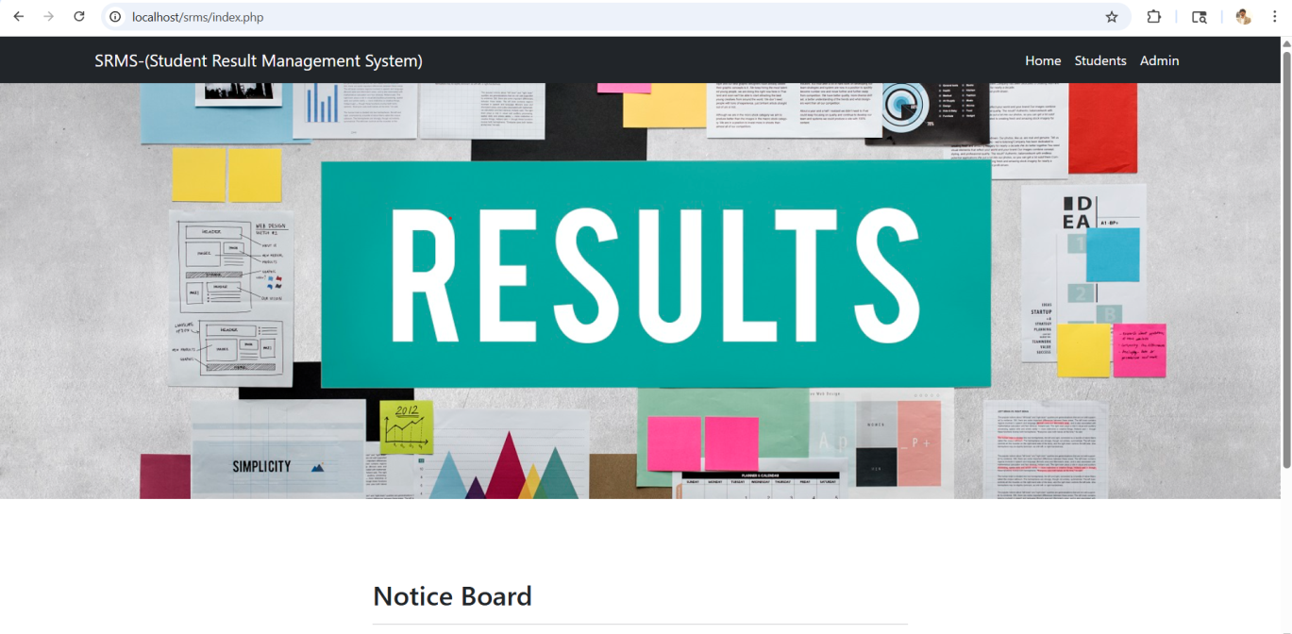

STUDENT LOGIN:

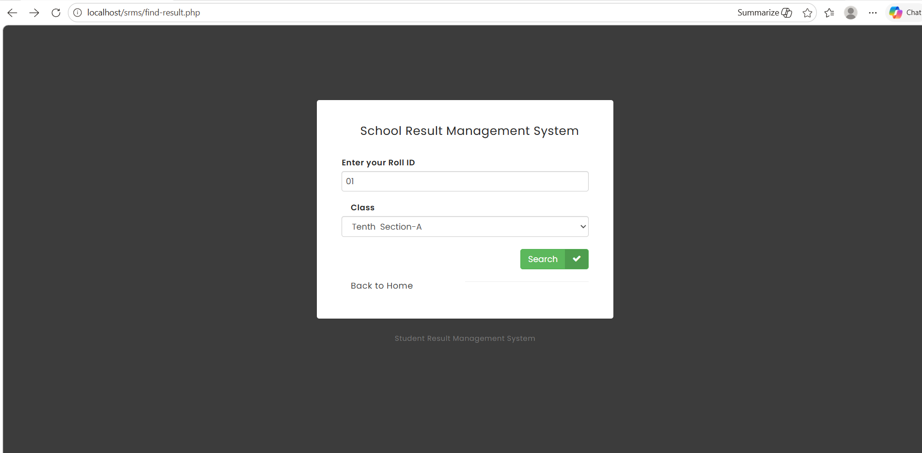

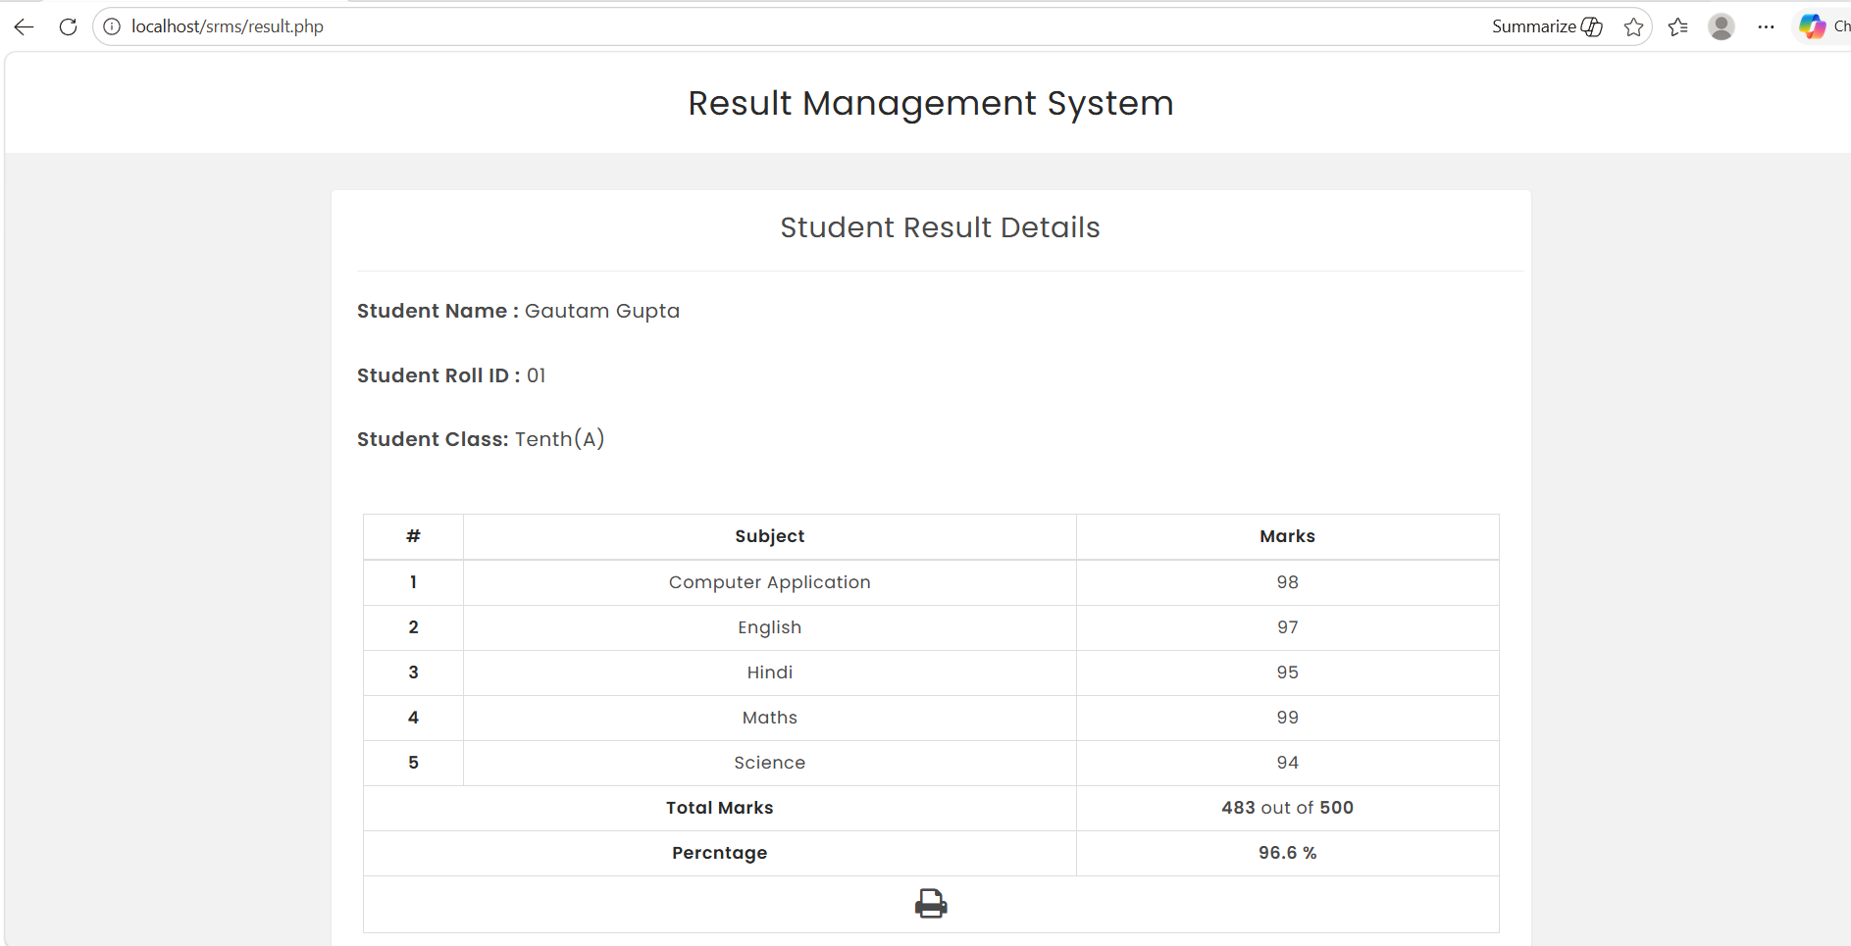

ADMIN LOGIN:

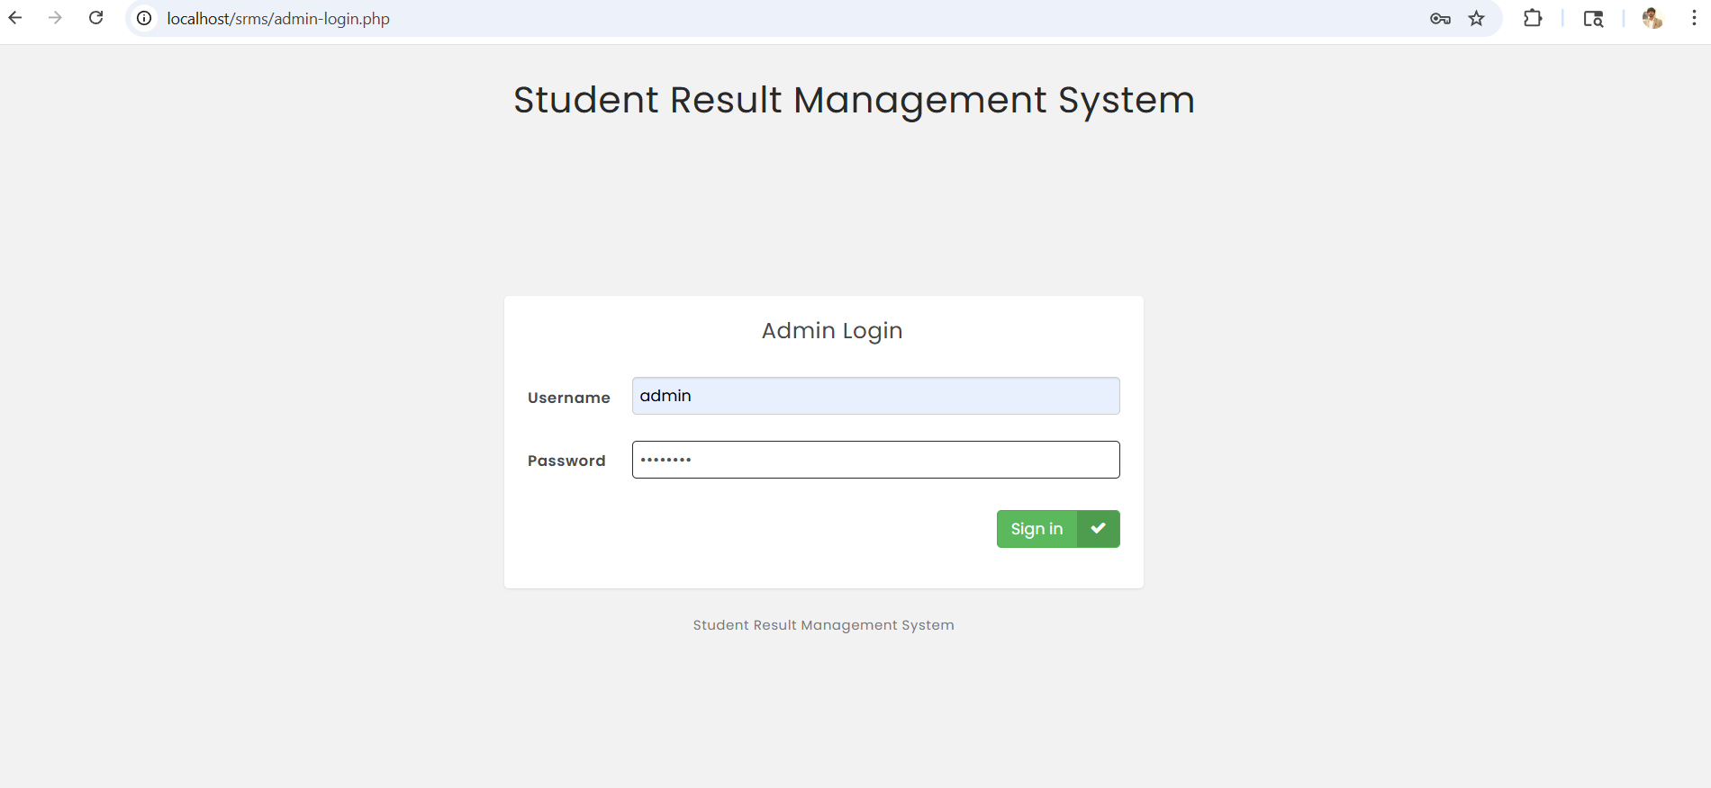

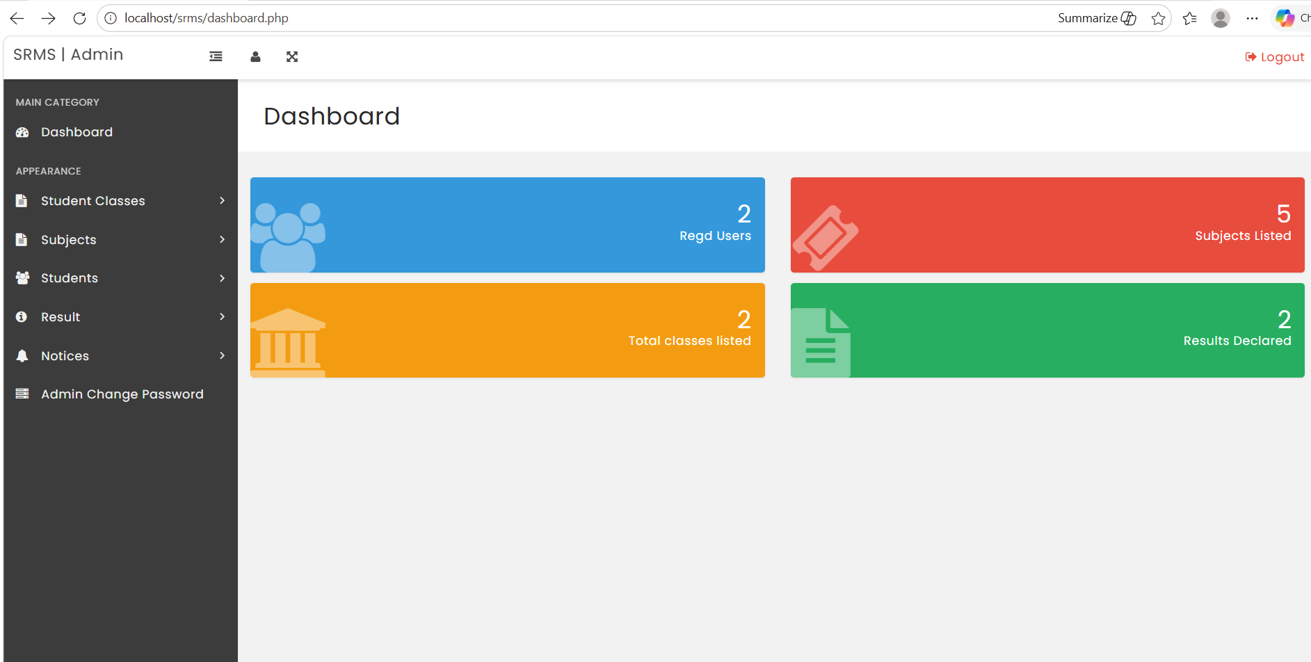

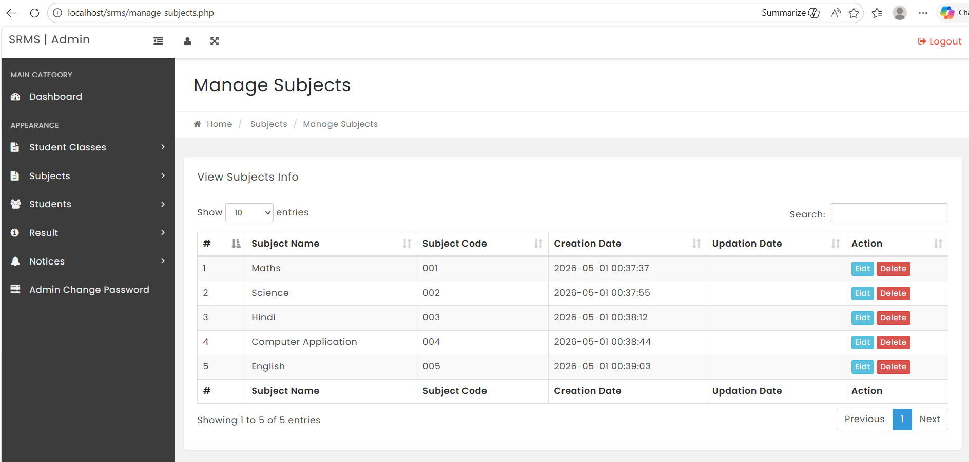

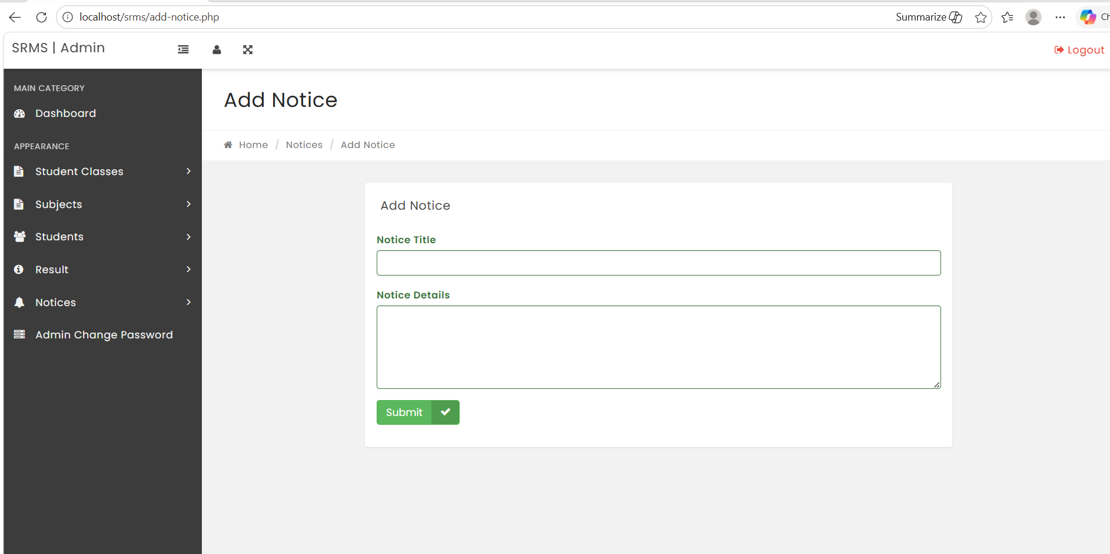

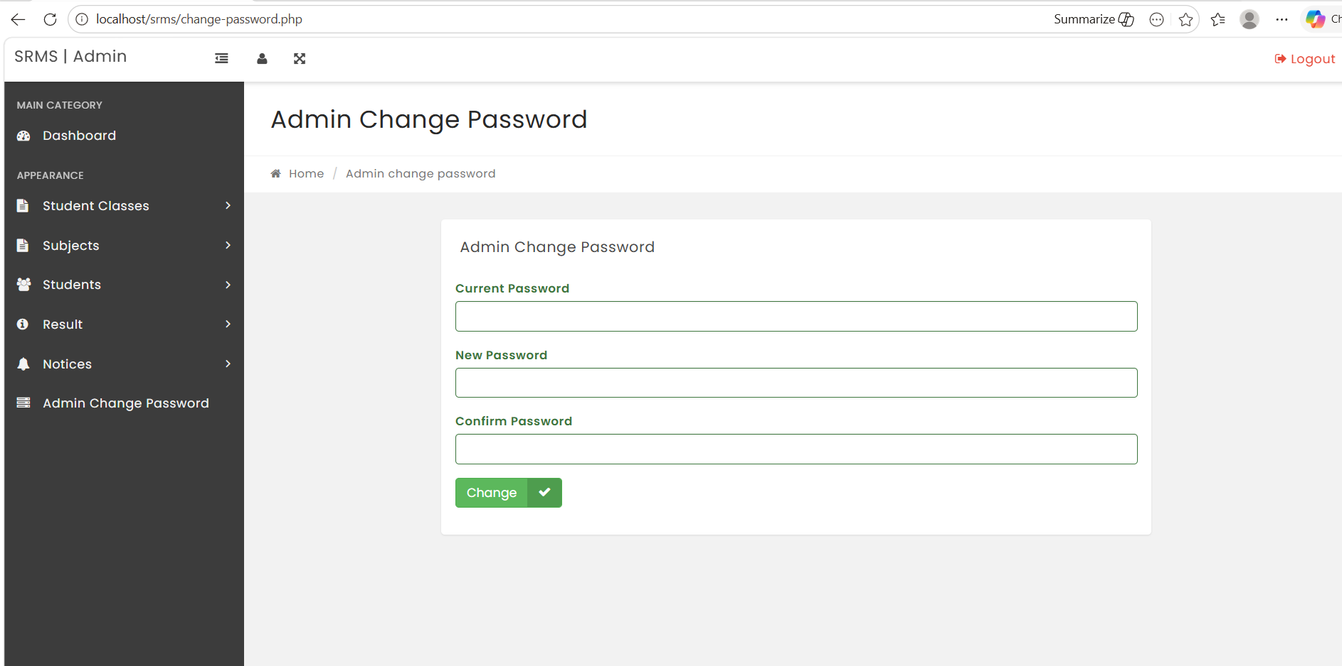

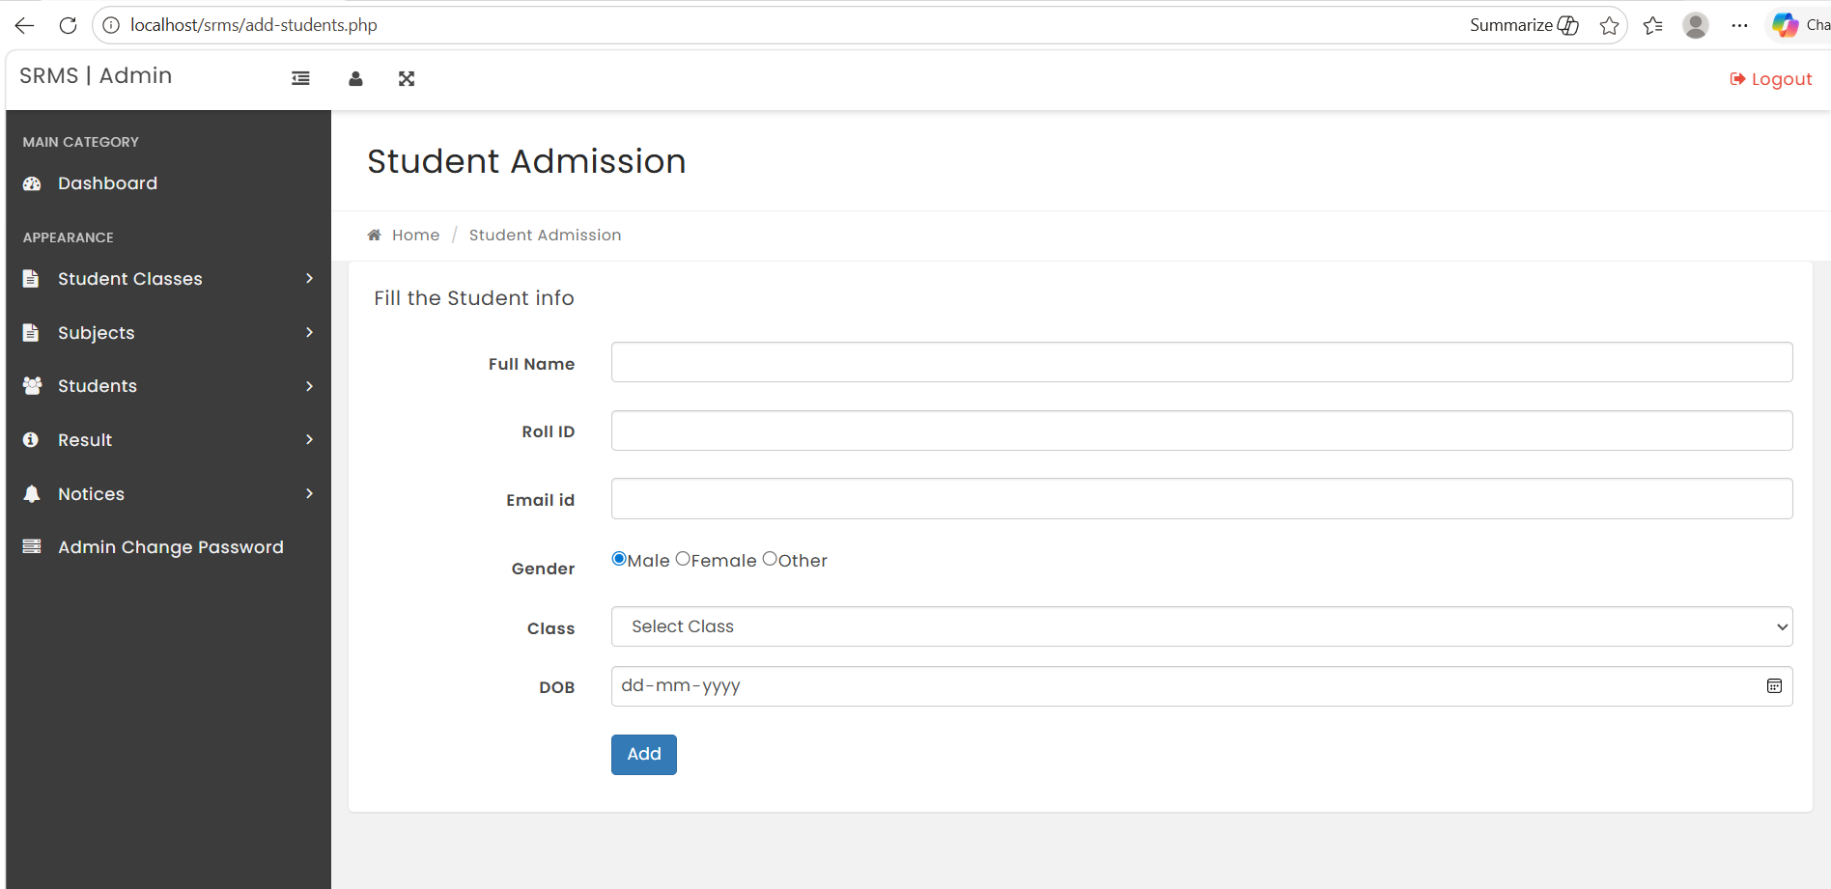

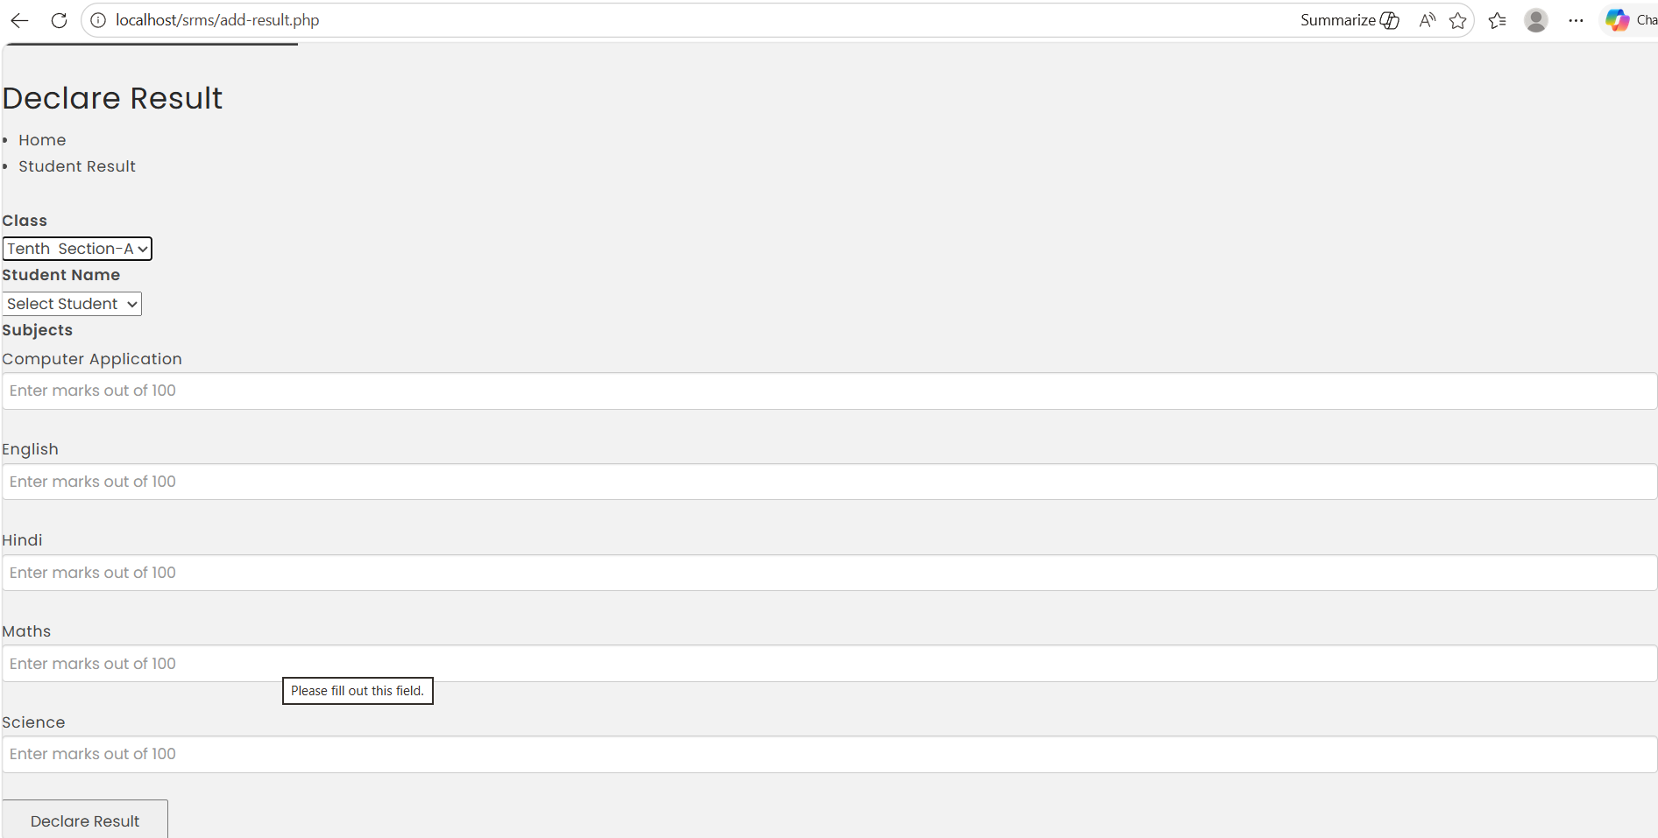

BIBLIOGRAPHY&REFERENCE

- Welling, L., & Thomson, L. (2016). PHP and MySQL Web Development (5th ed.). Addison-Wesley Professional.
- Duckett, J. (2014). Web Design with HTML, CSS, JavaScript and jQuery Set. Wiley.
- Nixon, R. (2014). Learning PHP, MySQL & JavaScript: With jQuery, CSS & HTML5 (4th ed.). O'Reilly Media.
- PHP Documentation. (n.d.). PHP Manual. Retrieved from https://www.php.net/manual/en/
- MySQL Documentation. (n.d.). MySQL 8.0 Reference Manual. Retrieved from https://dev.mysql.com/doc/refman/8.0/en/
- Bootstrap Documentation. (n.d.). Bootstrap 3.3. Retrieved from https://getbootstrap.com/docs/3.3/
- jQuery Documentation. (n.d.). jQuery API Documentation. Retrieved from https://api.jquery.com/
- W3Schools. (n.d.). PHP 5 Tutorial. Retrieved from https://www.w3schools.com/php/
- Stack Overflow. (Various authors). PHP, MySQL, JavaScript Q&A. Retrieved from https://stackoverflow.com/
- TutorialsPoint. (n.d.). PHP & MySQL Tutorials. Retrieved from https://www.tutorialspoint.com/

